**Kubernates**

Kubernates is an open-source container orchestration-engine or **container management tool** it automates deploying, scaling, and managing containerized applications.

So, if u observed the term container management tool this is self-explanatory that Kubernates will manage your containers at run time.

Explanation-

**Container**- as we know Docker is a Container where you can run any application like java, node js or angular. Kubernates will manage those applications which is running on your docker container.

**Management**- When I say Kubernates manages the applications it means Kubernates will take care of deploying, scaling, scheduling, and load balancing your applications which is running in our docker containers. That’s why this is called as a container management tool or container orchestration engine. This is what the containers activities deploying, scaling, scheduling, and load . on behalf of you Kubernates will take cares these activities if you are running your application on container platform.

**Tool**-

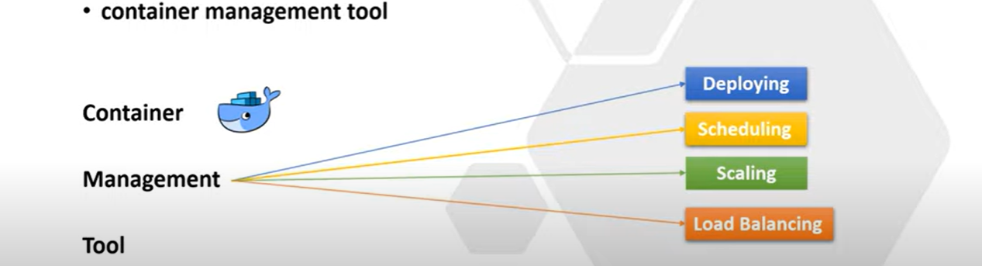

**Use Case**- why Kubernates came into picture.

Let’s say I have 2 microservices **Microservice**-**1** and **Microservice**-**2** and each microservices connect to their own databases. Both the microservices can communicates with each other using kafka messaging queue and now I want to run the entire application in a container like docker. So what I need to do.

-> first, I need to Dockerize the Microservice-1, since this is my spring boot application, so I need to create the docker image of microservice-1 which is nothing the dockerizing the microservice-1. Then I will deploy the microservice-1 in a **container-1**.

-> similarly, I need to Dockerize the Microservice-2 then I can run it in a **container-2.**

-> Then I can take the pull of kafka Image from Docker Registry or Docker Hub. Then I can run the kafka instance in **container-3**.

->Similar way I can take the pull of Database image from Docker-Hub, and I can run this particular database instance in **container-4**.

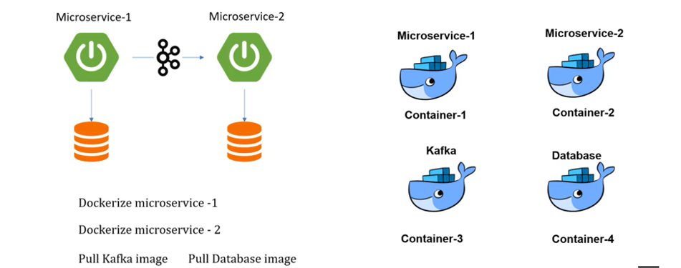

So, this is how I can run and deploy the multiple applications to multiple containers. Here I can able to manage the containers as well bcz the count is very less. But practically in real time we are not playing with only 4 containers. We are using n number of containers for each application. If you consider any Ecommerce application like Walmart, flipkart or amazon they use multiple containers to ensure availability so there is no application down time. Scalability to achieve the high performance. They must need to use multiple containers and its not easy to manage that much containers manually. When I say manages means it includes deploying, scheduling, scaling, load balancing, monitoring and batch execution all these things is difficult to manage manually.

That’s why Kubernates came into picture. You just write your code and push your image into container like docker then everything Kubernates will take care.

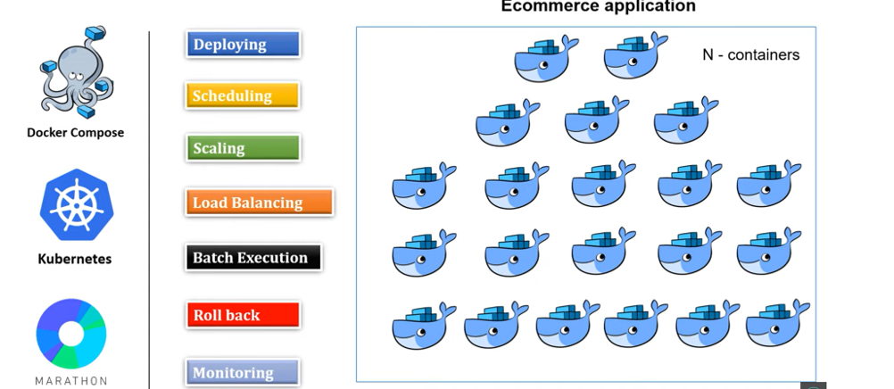

In the above tutorial, we just discussed the basic introduction of Kubernetes, right? Where you understand what is Kubernetes and why we need it in the microservice world So now let's move one step ahead and deep dive into components of Kubernetes.

Before we start let me tell you this is very important session You must need to know each component before you start working with Kubernetes.

**K8S Components Explanation**

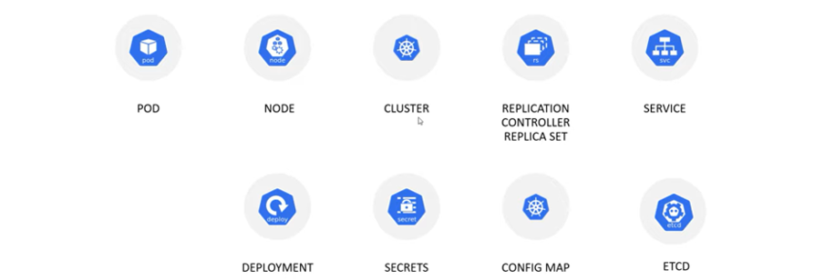

So, these are the Kubernetes components **pod, node, cluster, replication controller and replica set Service, deployment, secrets, config map and etcd**. Okay. So, these are the Kubernetes components

**POD & Node & Cluster-**

I will explain each and every component. Let's begin with what is pod and node Okay in Kubernetes, we are not interact with container directly. The containers are wrapped into a functional unit that is called pods Okay And a pod can have a single container or it can have multiple container inside it and each pod associated to a single IP address That's how one pod can talk to another pod and there is another virtual or physical machine where all pods wrapped into it that is called node Okay, so a node can have a single pod or it can have a multiple pods okay, now again multiple node wrapped into another physical unit that is called cluster so cluster either can have a single node or it can have multiple node .Kubernetes cluster are comprised of one master node and a number of worker nodes. These nodes can either be a physical computers or virtual machines depending on the cluster you created Okay, now if you'll try to understand from backward direction we have a cluster and inside the cluster we can have a single node or multiple nodes and inside each node you can have a single pod or multiple pods and inside a pod either you can have a single containers or multiple containers Okay, so far at high level we understand what is pod, node and cluster Right

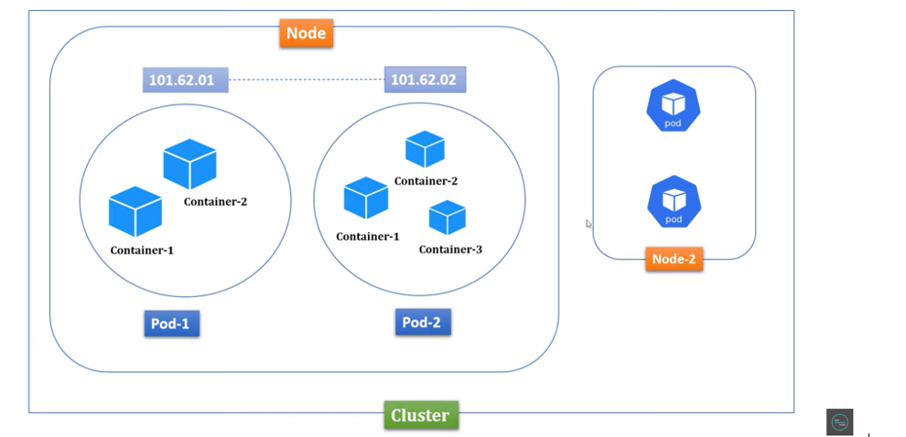

**Replica Sets-**

As you understand in previous slide that pods are running inside a node and each pod associated to a unique IP address Now let's assume I have pulled database image and running that containers inside a pod so let me name this pod as a database pod Okay, as you know each application always need to interact with database But let's assume due to some memory or CPU problem my database pod got crashed Now how my application will handle all the traffic which is coming to this database pods Which is not running, it may leads huge cost impact to my application, isn't it? So how to overcome this or how can I ensure that there is no application downtime That's where replica set component came into picture Which will act as a replica or backup of your pod For example, let's say I created three replica for my database pod When any of your pod will crash Immediately Kubernetes will bring up the new pod from replica set And it will assign a new IP to that specific pod You can create as many replica you want for a specific pod And these things you need to specify at the time of creating the deployment object I will talk about deployment object in a moment So far we understand how this replica set works, right?

If there is any pods goes down or some pod got crashed Immediately it will replace a new pod with a new IP address .

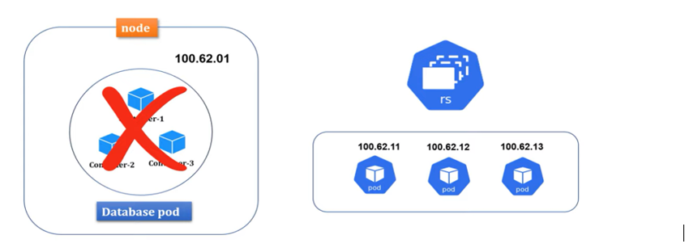

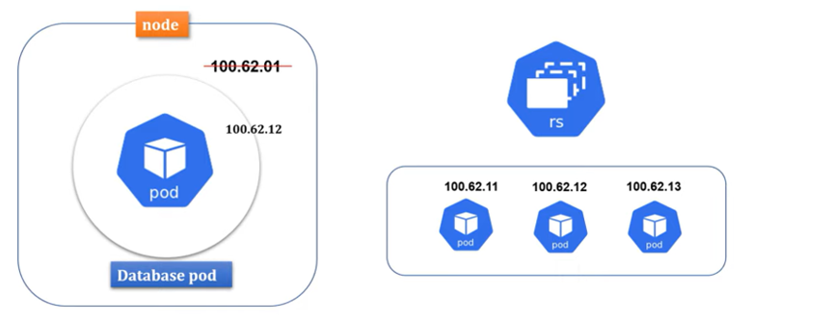

**Service-**

Now let's move into the next component that is service So as you know inside a node, we can have multiple pods. Let's name this pod as a front-end pod where my angular or client application is running and another pod I will name it as a back-end pod Where my server-side code or spring boot application is running and each pod assigned to an unique IP address That's how they can connect to each other, right?

Front-end pod can talk to the back-end pod using the IP address Also we understand if any pod die Then immediately replica set will bring up a new pod with new IP address but what if this will keep going? I mean due to some problem pods are keep dying and replacing with new pod with new IP address In such kind of situation my front-end pod can connect to the back-end pod Because IP is keep changing, right? That's where service came into the picture Now each pod will associate to one service or multiple pods can group together into a single service with label and selector I will talk about this label and selector in my future session with an example But for now let's assume one pod associate to one service, ok? Where service will provide a static IP and DNS name So going forward each pod can talk to each other using DNS name Rather than using the IP address, ok? Let's say if back-end pod down Then under the replica set will replace a new back-end pod It won't impact to the front-end pod Because front-end pod still can able to connect to the back-end pod With service DNS name Because the life cycle of pods and service completely different That's pretty cool, isn't it? Apart from managing the service discovery role Service also play the role of load balancer Where traffic coming to your pods will be handled by service Then service will redirect to available pods based on your loads There are different service type used in Kubernetes Like cluster IP, node pod and load balancer This service differ by how you expose your pods internally or externally And how you handle the traffic So I am not going to deep dive types of service now We will understand this in our coming session with an example So I hope you understand enough information about service component.

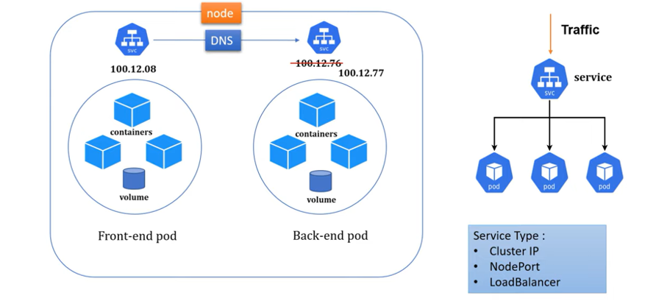

**Deployment-**

Now let's move into the next component which is deployment. Deployment are Kubernetes object that are used for managing pods. You can scale your application by increasing the number of running pods or you can update the running application using deployment object Also you can configure number of pods, CPU, memory, everything Through this particular deployment object If you can observe below command

**kubectl create deployment first-deployment -image=<DOCKERIMAGE_NAME> --port=8080 --replicas=4**

Here we are telling to the Kubernetes that create a deployment object With name first deployment Then pull image from local docker repository or from docker hub And then create an active pod with 4 replica pods Which you can consider as a just a blueprint or backup of your actual pods So instead of using this command to create deployment object You can also use the YML file which is nothing Deployment.yml file and you can create a deployment object with that. So in an example when we will do a Spring Boot cloud application I will show you how you can create the deployment object Using both command prompt as well as the YML file approach.

**Secrets & ConfigMap**

Now let's move into the next component which is secrets and config map First of all both secrets and config map use to store sensitive information of your application Like password, secrets key or API key Let's say I deployed one Spring Boot cloud application to Kubernetes Usually we do configure our database properties in Spring Boot application.properties file Or application.yml file Which is not secure If any changes done in configuration Again you need to rebuild your docker image Then you need to deploy it to the container Which is kind of rework for a developer Why not we will separately manage this sensitive info outside of our application Since we are using containerization platform Why not we will directly use Kubernetes component to store my sensitive information That's why to manage secrets and configuration of your application Kubernetes provided two components Secrets and config map These two are placed outside of pods If you observe Secrets and config map present outside of the pods So that inside a node if there is multiple pods They can point to the same secrets and config map They can reuse the secrets which they configured in the secret object

And the main purpose of using two different components to store sensitive information Is that where in secret you can add sensitive information with encrypted format However in config map it will store as a plain text Let's say for example you are configuring your data source properties Then only the password you can configure inside the secret And rest other URL, driver class name and user name You can configure inside the config map object .

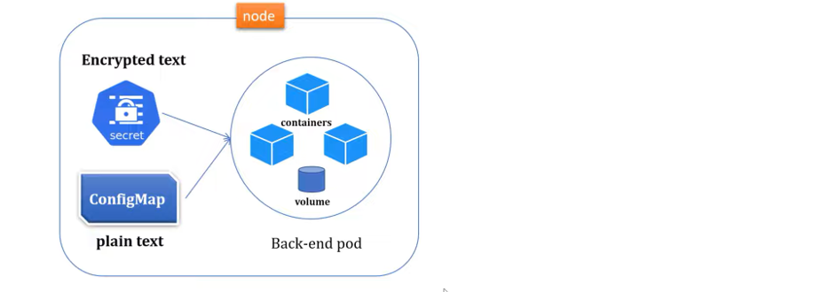

**ETCD-**

Now let's move into the next component Which is etcd, Kubernetes used etcd as a key value database It store the configuration of the Kubernetes cluster inside the etcd Also it stores all the secrets and config map data inside etcd database And the max limit is 1 MB to store secrets So this is what all about etcd, config map and secrets We will discuss more about these three components When we will deploy a cloud application to Kubernetes So I believe you understand good amount of context about components of Kubernetes So what all components we will learn today In my coming session we will demonstrate all with real time example.

**Kubernetes Basics & Architecture**

In the previous tutorial, we understand components of Kubernetes. Let me give you some basic overview about pod, node and cluster what we discussed in our last tutorial. As you know, in Kubernetes, we are not interact with containers directly. The containers are wrapped into a functional unit that is called pod. So, a pod can have either a single container or it can have multiple containers and each pod associated to a unique IP address that's how one pod can talk to another pod. And there is another virtual or physical machine where all pod wrapped into it that is called node. Okay, so a node either can have a single pod or it can have a multiple pod. Now again, multiple nodes wrapped into another physical unit that is called cluster. So, in a cluster, it can have either a single node or it can have multiple nodes. So, this is what we understand about pod, node, and cluster in our previous tutorial. Right. Now in this tutorial, let's discuss basic architecture of Kubernetes. Before we start learning the architecture of Kubernetes, you must have basic knowledge about its components.

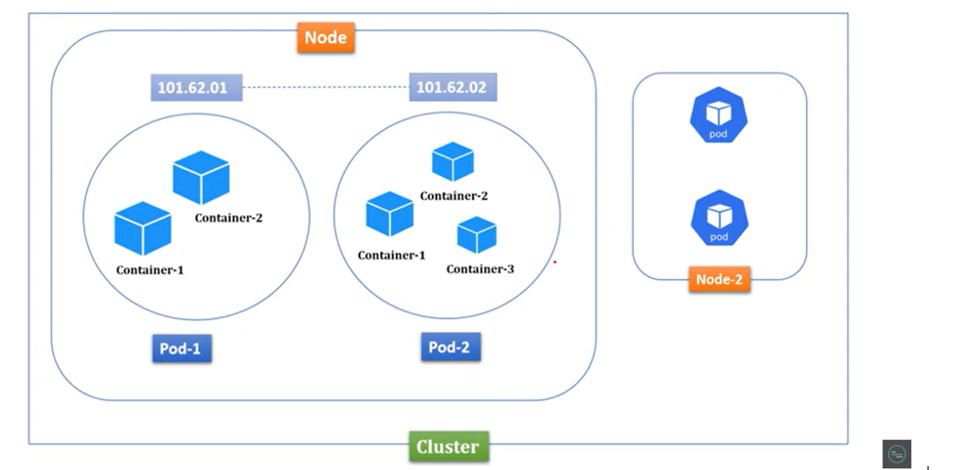

let's go through a simple example.

In an organization, there is a manager who usually manages multiple projects and each project assigned with multiple developers. Right. Now what is the role of manager here? Manager will monitor all the projects whether it is running smoothly or not. Also, manager will check whether all developers are working or not. Apart from that, if any developer left from the project, immediately manager will assign a new resource to that specific project. Similarly, if any project getting closed or completed, then all the resource from that existing project manager will tag them to a new project. Right, this is what a manager does. Now let's link this term to Kubernetes component.

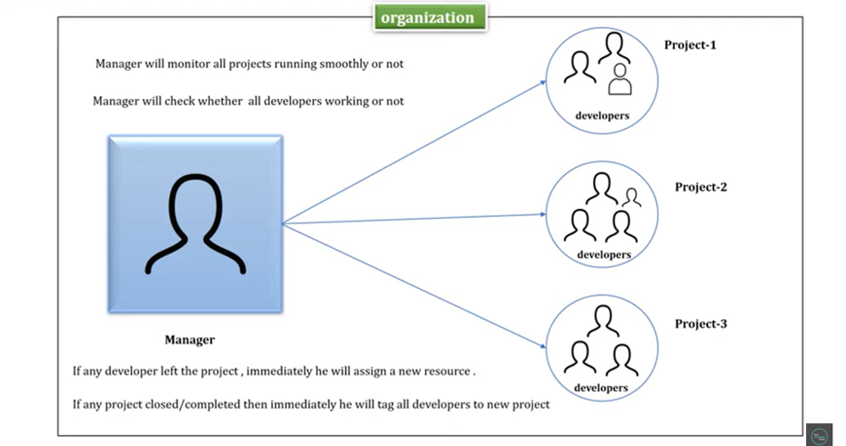

So, this organization, you can consider it as a cluster. And as you know, inside a cluster, we can have multiple nodes. So, you can consider manager as a master node and projects as a worker node. And also, we know inside a node, we can have single or multiple pods. Right, So you can consider developers as a pod inside a worker node. Okay. Since master node act as a manager, what you will do? Master node will monitor all the nodes whether it's running smoothly or not. It will monitor their health, resources, and memories. Master node will check whether all the pods are working or not. Similarly, if any pods are down inside a node, immediately he will assign a new pod with a new IP address. In case if any nodes are down, then immediately he will tag all the pods from the existing node to a new node. So, this is what all master node does.

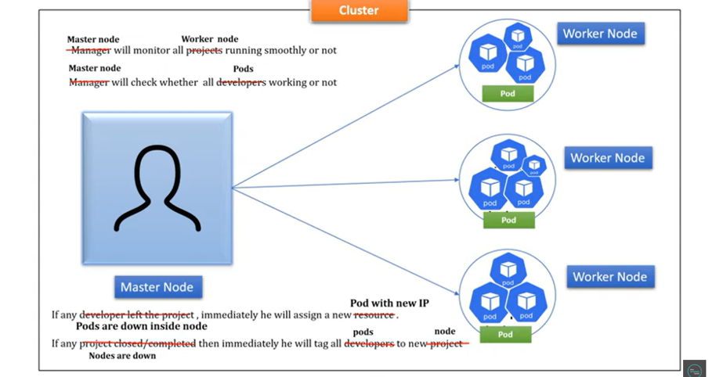

In Kubernetes, there should be a minimum single cluster and inside a cluster, there should be at least one master node and one worker node. Hope this concept is clear for you. This is what the basic architecture of Kubernetes. Now let's go deeper to understand more about components of master node and worker node. And also, we'll understand how master node will communicate with worker node.

**Master node and its components**

As you understand, master node manage the cluster and it basically monitors node and pod inside a cluster. Master node has four components, API server, scheduler, controller manager, and etcd database. We'll discuss each component one by one. Let's begin with API server. So, this API server will act as a cluster gateway. Each request coming to your cluster will first serve by API server. Basically, API server expose few API to access all the operation going on inside a cluster. You can access API server either using command line tool, which is kubectl or you can use Kubernetes user interface. Let's say I want to check health of my pods or nodes. Then simply I can run the kubectl command kubectl get nodes or kubectl get pods. Once I run this command, request will not go directly to your worker node. Just the request will be intercepted by API server. Then API server will check all the worker node and pod running inside it. Then it will give you the status of your pods and nodes. Okay. So, this is what the API server does in master node. It will just act as a cluster gateway, or it will just act as an entry point of your master node. Okay. Now the next component is scheduler. Scheduler usually plays a critical role in a master node. It usually schedules pods across multiple nodes. For example, let's say you have two worker nodes, and you want to scale up your application. So, for that, definitely you have to increase pod count, right? That's where the scheduler helps you. What scheduler does, it will go and check memory and CPU usage of each worker node and based on availability, it will schedule pods to that specific node. And if you observe the first worker node utilized 90% of its CPU and the second worker node already utilized 30% of its CPU, then the scheduler will schedule the pod inside the worker node 2, not inside worker node 1 because this worker node 1 already used 90% of its CPU and this worker node 2 is free here, right? It only used 30%. That's how scheduler take the decision on which node new pod should be scheduled.

Now you might have a question. How does the scheduler know all the information about node and pod, right? As you know, Kubernetes internally use an etcd key value pair distributed database. It stores all the information about your cluster and its states and from etcd, API server fetch all the cluster info and you share that information to the scheduler. That's how the scheduler works. Now the next component is controller manager, which is another crucial component. So, what controller manager does is it detects cluster state change like pod crashing or node crashing. When a pod crashed, then immediately Kubernetes bring up a new pod from replica set and then controller manager will talk to the scheduler to schedule a new pod to a available nodes. Okay. And again, controller manager manages to the multiple controllers like node controller, replication controller, endpoints controller, service account and token controller, where node controller monitor and respond all nodes activity, replication controller monitor health of pod. If any pod goes down, then immediately you'll take the action. Endpoints controller is responsible for manage all service and their communication. Similarly, service account and token controller is responsible for maintaining account, API access and namespace. So these are four components of master node. Usually, they keep monitoring the health of your cluster. We'll practically understand this when we deploy our first application to Kubernetes.

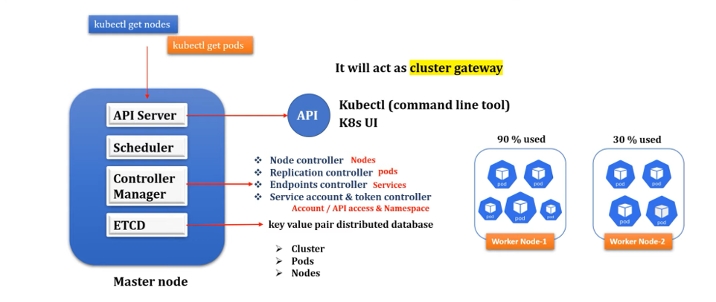

**Worker Node & its component**

As you already know, a worker node is nothing. It's just a virtual or physical machine. And inside a worker node, we can have multiple pod and each pod can have either single containers or multiple containers inside it. Right. Worker node has three components, kubelet, kubeproxy and container runtime. Let's discuss one by one.

Kubelet is an agent running on each node and kubelet communicate with master node using API server. The kubelet works in terms of pod spec. A pod spec is a YML or JSON object that describes all about your pods. So, what kubelet does, it takes a set of pod spec that are provided through various mechanism, and it ensures that the containers described inside those pod spec are running healthy. Okay, and this kubelet only manage the containers which was created by Kubernetes only.

Now the next component is kubeproxy. kubeproxy is a network agent which runs on each node and it is responsible for maintaining network configuration and rules. These rules allow network communication to your pods from inside or outside of your cluster. Basically, it helps you to expose your services to the outside of your world. kubeproxy also communicate with master node using API server.

Now the next component is container runtime. A container runtime also known as a container engine, and it helps to run containers which is running inside a pod. As you know in Kubernetes, we can't directly access the containers. So, all the containers are wrapped inside a functional unit called pods. That's where our application is running. Right, and these containers engine provide runtime support to all the containers which are running inside a pod. So, these are the basic component of Kubernetes worker node.

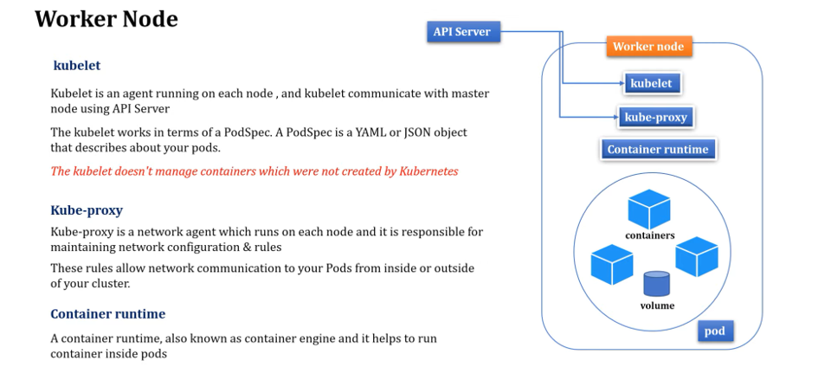

Now you understand what is master node and also you understand what is worker node. Right. And master node can communicate with the worker node with the help of API server. So, this kubelet and kubeproxy from worker node will communicate to the API server and they can share the information about all the worker nodes. OK So, this is what the basic architecture of Kubernetes. So, I hope you understand good amount of knowledge about Kubernetes components and its architecture.

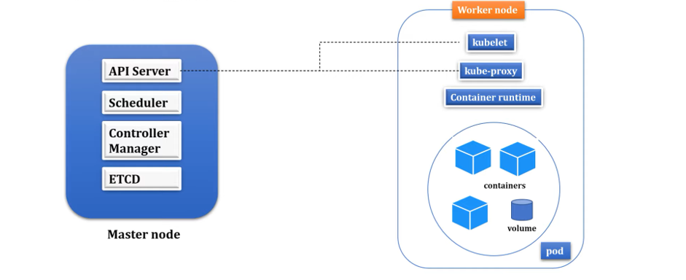

**Setup Kubernetes in Windows & Run Spring boot application on k8s cluster**

**Minikube Installation**

**>> What is Minikube**

**>> Minikube Installation in Windows**

**>> How to deploy first Springboot application to Kubernates Cluster.**

How to install Minikube in Windows operating system and also, I will demonstrate how to deploy your first spring boot application in Kubernetes cluster.

Before we install this Minikube, first let's understand what this Minikube is and why we need it. So let me quickly brush up the basic architecture of pod, node and cluster to explain you why we need Minikube. As we know, In Kubernetes, we have a cluster and inside this cluster, we can have either single node or we can have multiple nodes and inside this node, we can have a single pod or we can have multiple pods inside this node and again inside this pod, either we can have a single container, or we can have multiple containers and this container is the platform where you can run your application. The application can be spring boot, or it can be angular or any technology specific application, you can run inside containers which is present inside pods.

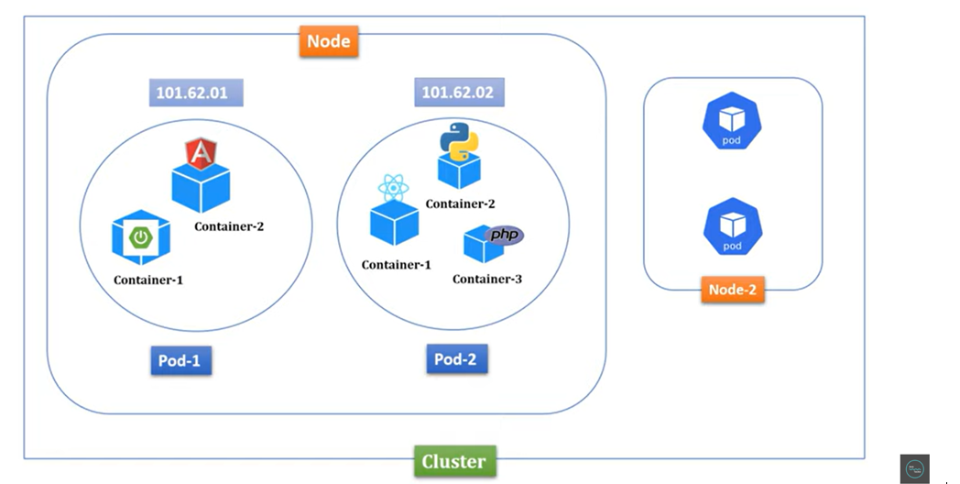

Now if you understand this basic architecture to run an application in Kubernetes, you need this cluster infrastructure like you need pod nodes in your machine. How will you get this infrastructure? That's where this Minikube utility or tool came into picture. To run Kubernetes cluster in your local machine or computer, you need to install this Minikube tool. Minikube runs a single node Kubernetes cluster on your machine so that you can try out Kubernetes for your daily development work. So, if you install Minikube, then you will get a cluster and node, then you can host any containerized application inside it. So, let's try this out.

**install kubectl**: https://kubernetes.io/docs/tasks/tools/install-kubectl-windows/

**install Minikube** : https://minikube.sigs.k8s.io/docs/start/

**install Docker Desktop** : https://docs.docker.com/desktop/install/windows-install/

First step, we need to install Minikube. So let me walk you through the steps of installation process. So, install and set up kubectl.

So, what kubectl does, kubectl is a command line tool. Using kubectl, we can connect to Kubernetes cluster from our local machine. So that's the reason first we need to install this kubectl command line tool. And for Windows, you can directly download the latest release version. Just click on this. It will download the kubectl.exe. Now next step, you need to install the Minikube utility for Windows. So just click on this Windows. This is what installing Minikube. Just click on this. Now if you scroll down, you can find this Minikube Windows AMD64. Just right click on it, open it in a new tab. Now if you scroll down, for Windows, yeah, this is for Windows, right? Minikube Windows AMD64.exe. Just download it. Once you download this, then as per the documentation, rename it to the Minikube.exe. So let me go to the download folder. And I'll just rename this to the Minikube.exe. Just click on the rename. And I'll just add Minikube. So, I can remove everything here. Fine.

Now the next step, Minikube and kubectl, these are the two exe files you downloaded. Now let me copy these two files. Then I'll create a separate folder inside any directory. So, I'll just create a folder inside C. Now I'll just create a folder with name. Let me open the folder. I'll just name it Minikube. Inside this particular Minikube folder, I'll paste these two exe files. Now go to the download. I just want to delete these two. Now if you go inside the C, inside the Minikube, we have these two exe files, kubectl and Minikube. Now to access these kubectl and Minikube directly from the command prompt, I need to set this path to my environment variable. So just copy this and just type in command prompt environment. You can see here, edit environment variable for your account. Just click on this. Then click on path. Click on edit. Just add a new. Just paste it. Okay. C colon Minikube. Now click on OK. Click on OK. Let me close this. Now let me open a command prompt. Then here I'll just type Minikube version. So, if you observe, this is what the Minikube version we just installed. Right And we can able to see that particular version. Now we are done with the Minikube setup in Windows.

**First you need to download the kubectl**

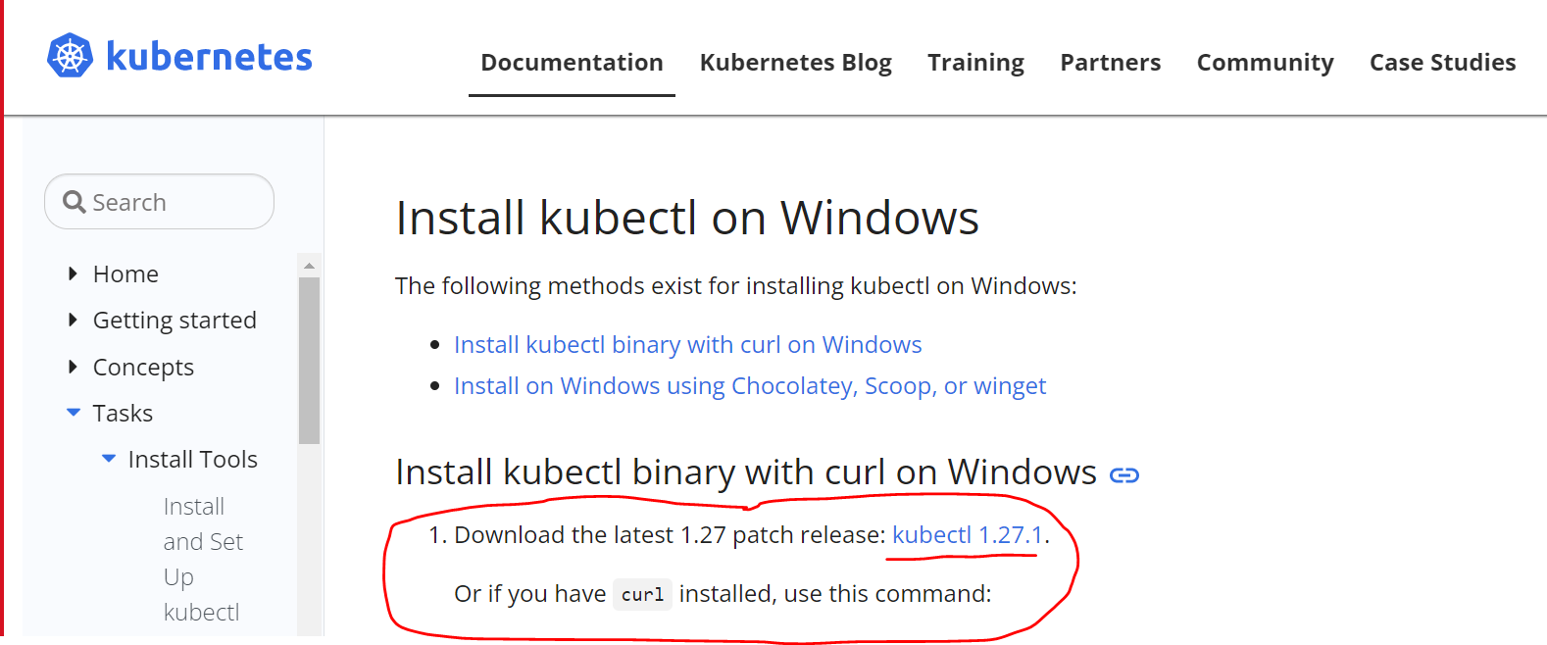

**Next you need to download the Minikube Utility for Windows**

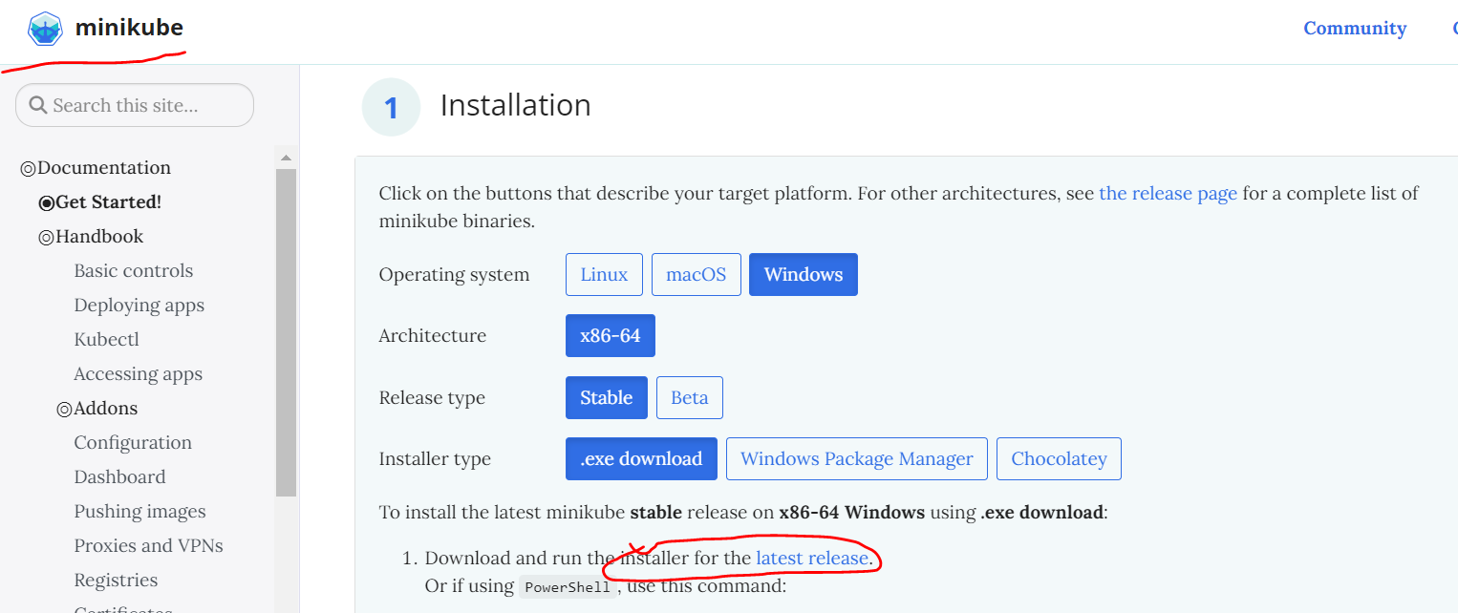

**Install Docker Desktop In your Machine.**

**Don’t enable wsl2 use Hyper-V for windows 10 for Docker Desktop**

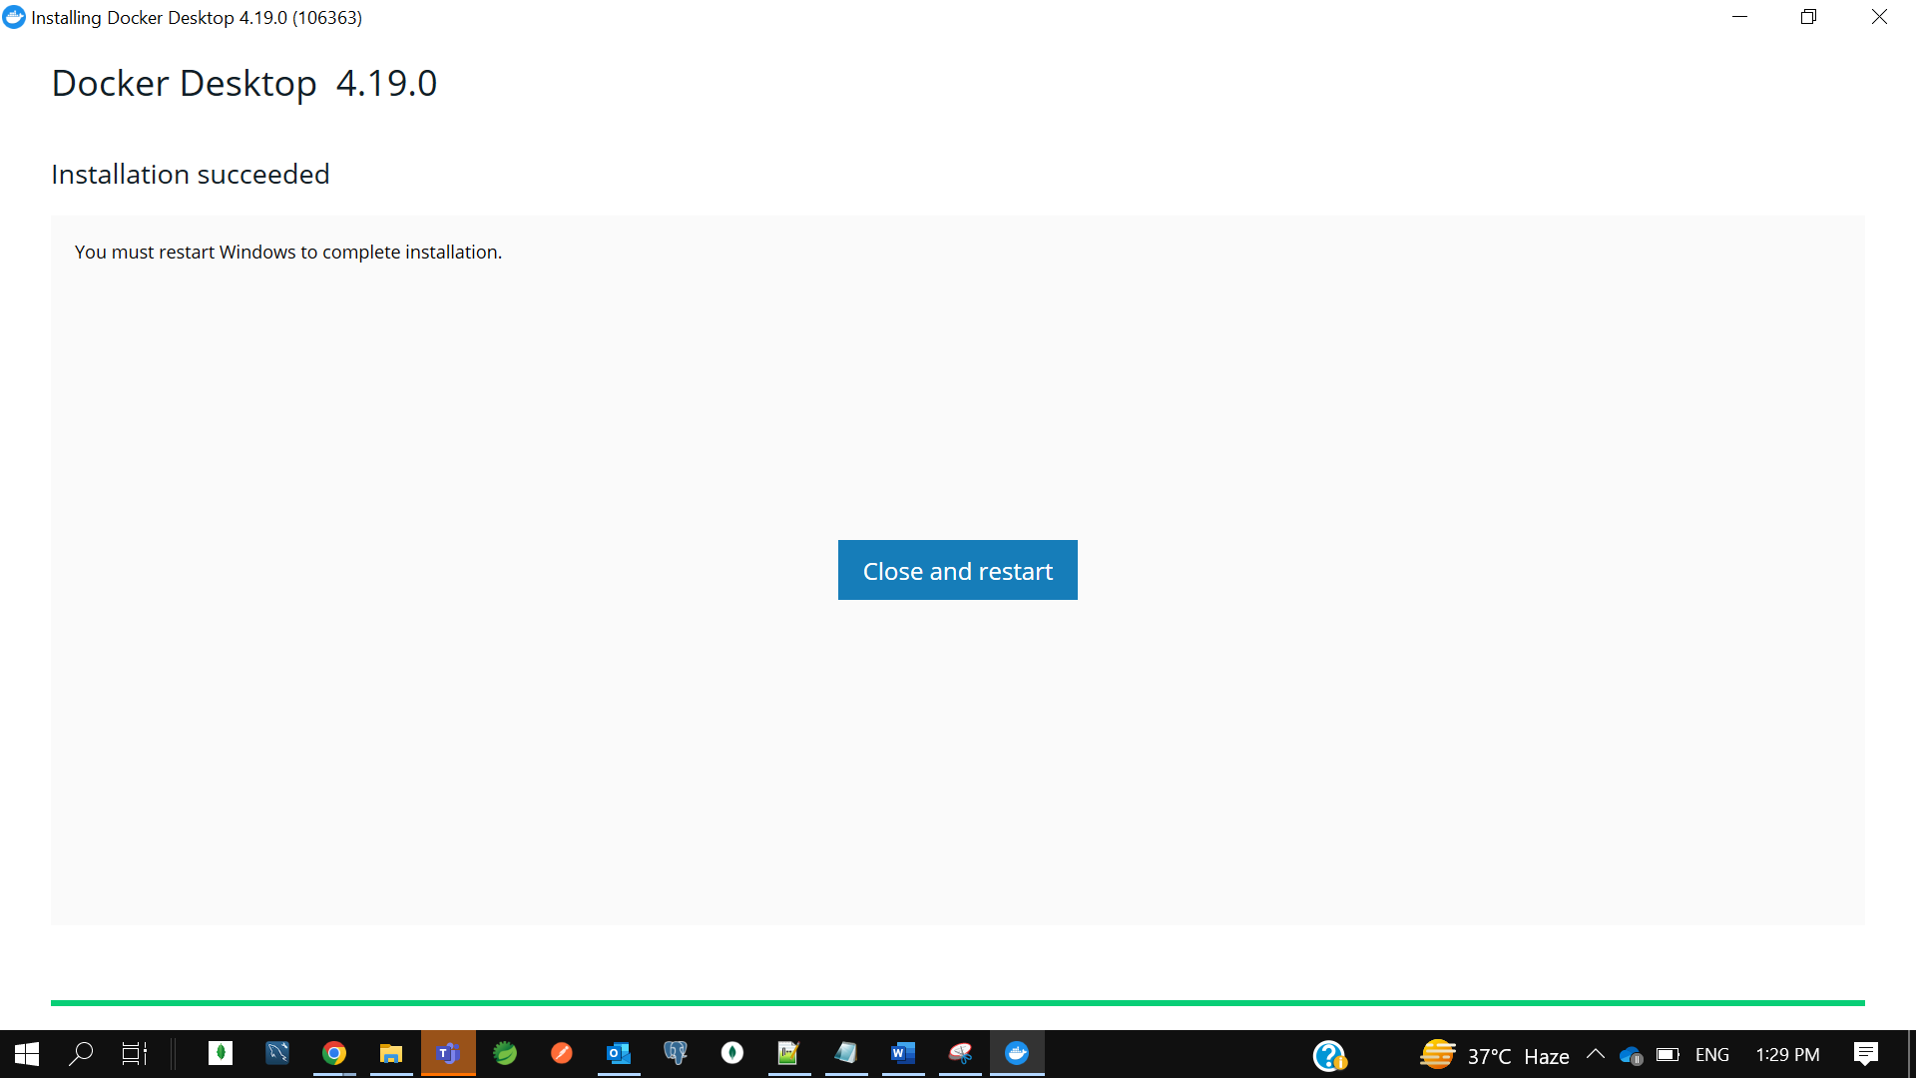

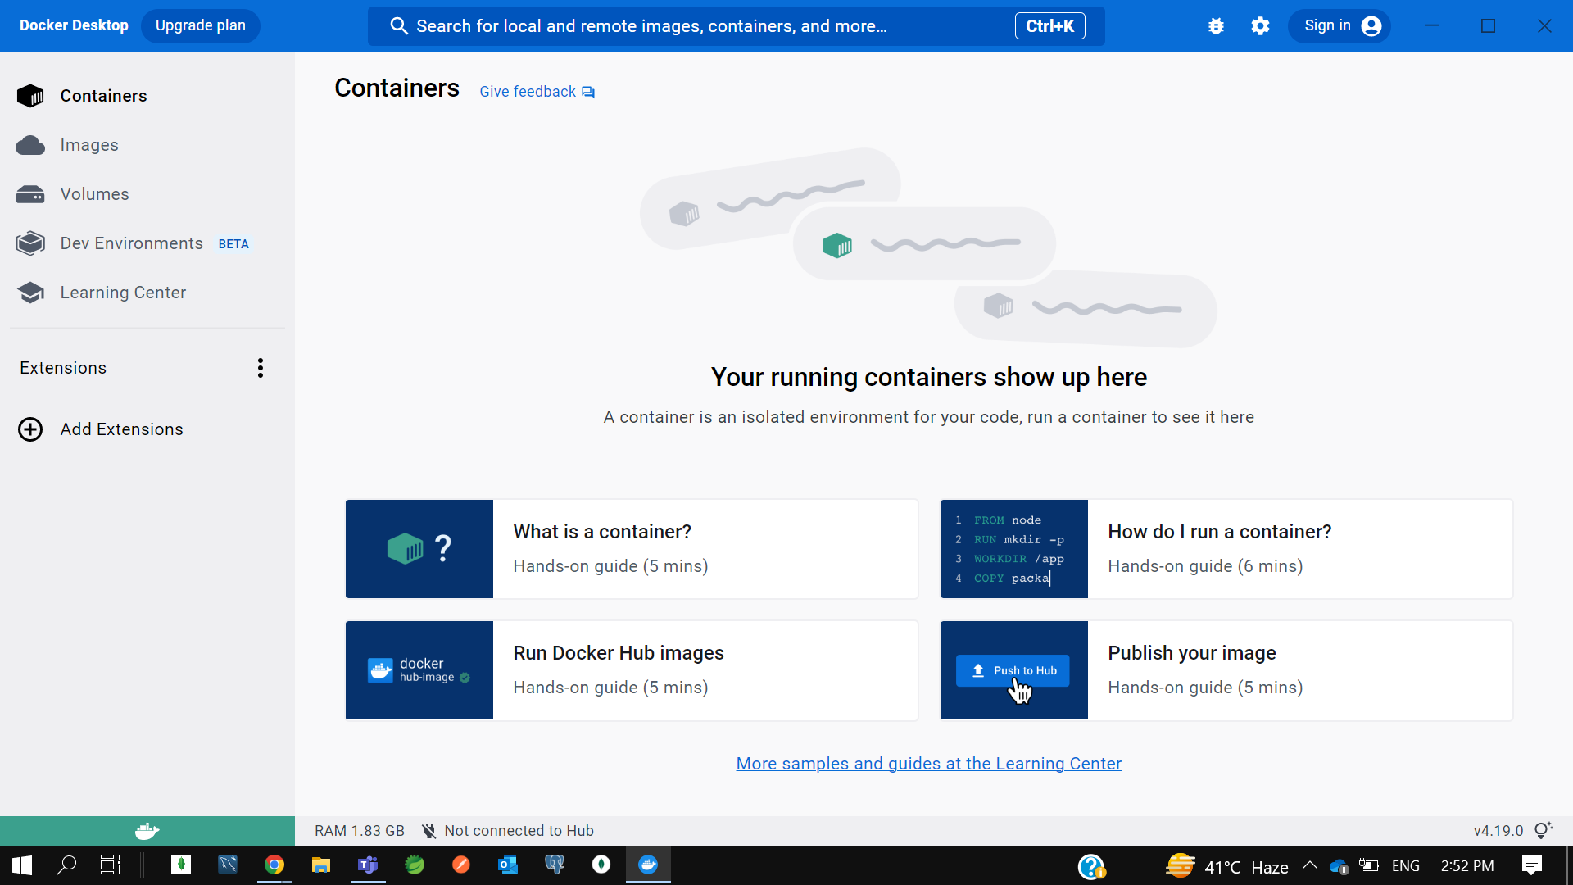

**To verify docker version---**

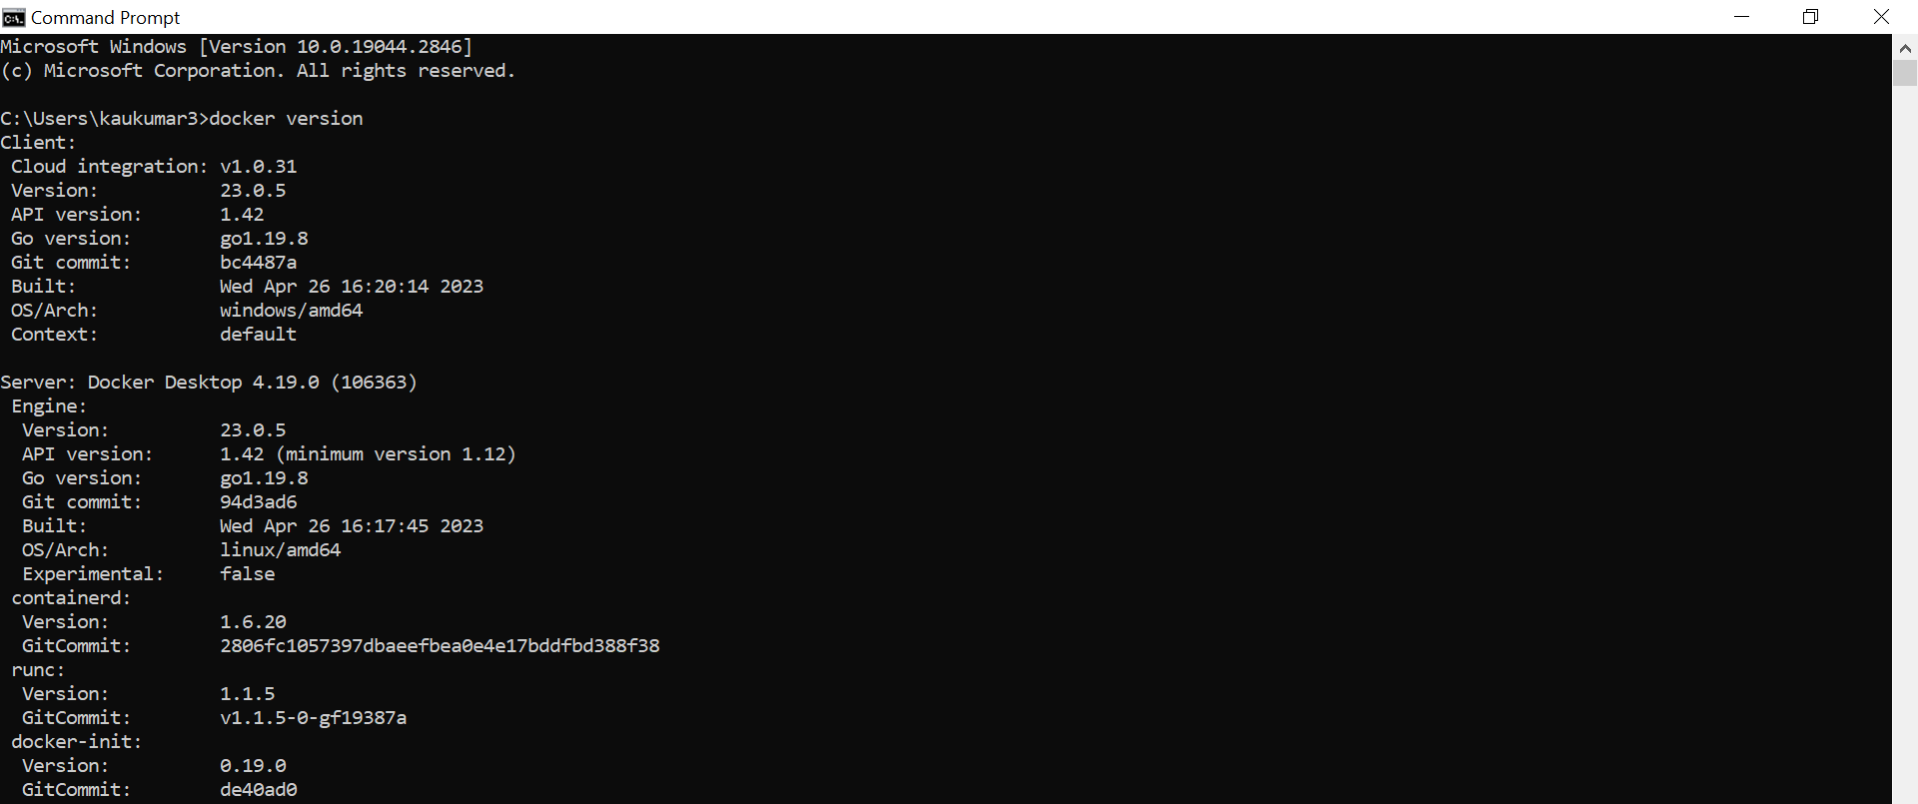

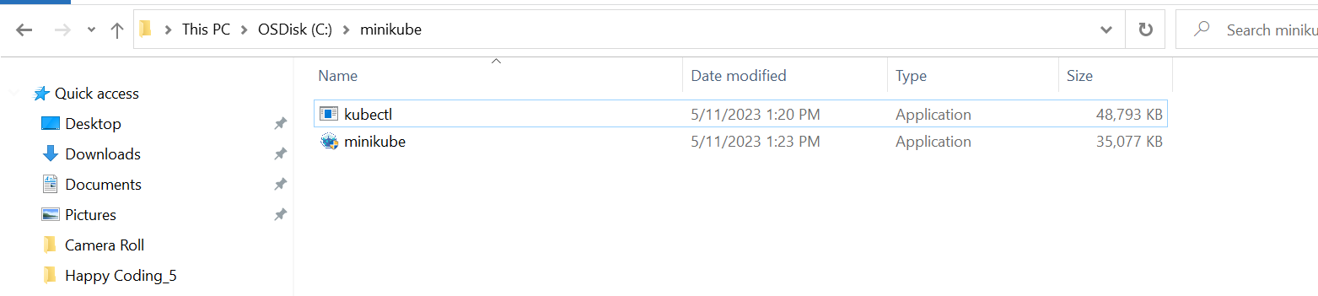

Environment-> User Variable -> Path-> C:\minikube

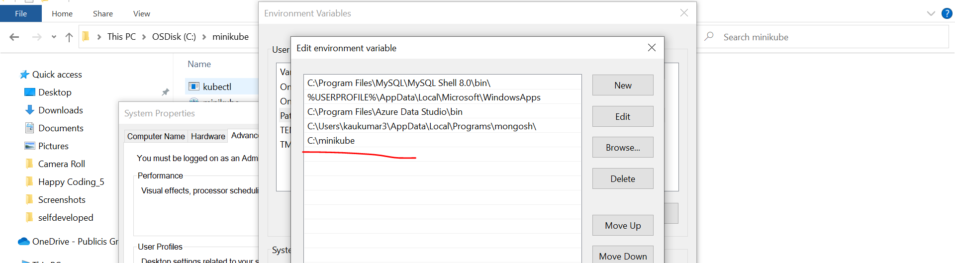

**If u verified the version using command prompt**

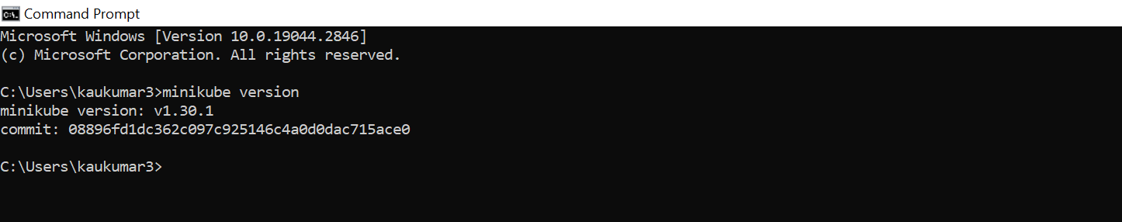

Now we have done with the Minikube setup in windows.

Now the next step, you need to start this Minikube. So, to start a Minikube, there is multiple drivers provided by Kubernetes. You can use any of them. Let me tell you all the available drivers to start a Minikube. Now if you'll go up, installing Minikube, there is a multiple driver**. You can use Hyper-V, you can use VirtualBox, or you can use Docker**. Now this Hyper-V will not applicable for all the Windows versions. If you are using Windows 10 Enterprise or Windows 10 Professional or Windows 10 Education, then only you can use this Hyper-V driver. Okay. If you want to use the VirtualBox, you should have enough space on your machine. Minimum you should have 16 GB RAM to use this VirtualBox.

Since I have installed Docker on my machine earlier, I can directly use the Docker as a driver to start the Minikube. So, to start Minikube with Docker driver, I can directly copy this command. Then I need to go to the command prompt, then paste it and then change the driver as a Docker here. Okay. But make sure Docker must need to be installed on your machine and it will up and running. Okay. Now let me run this command.

**-> minikube start**

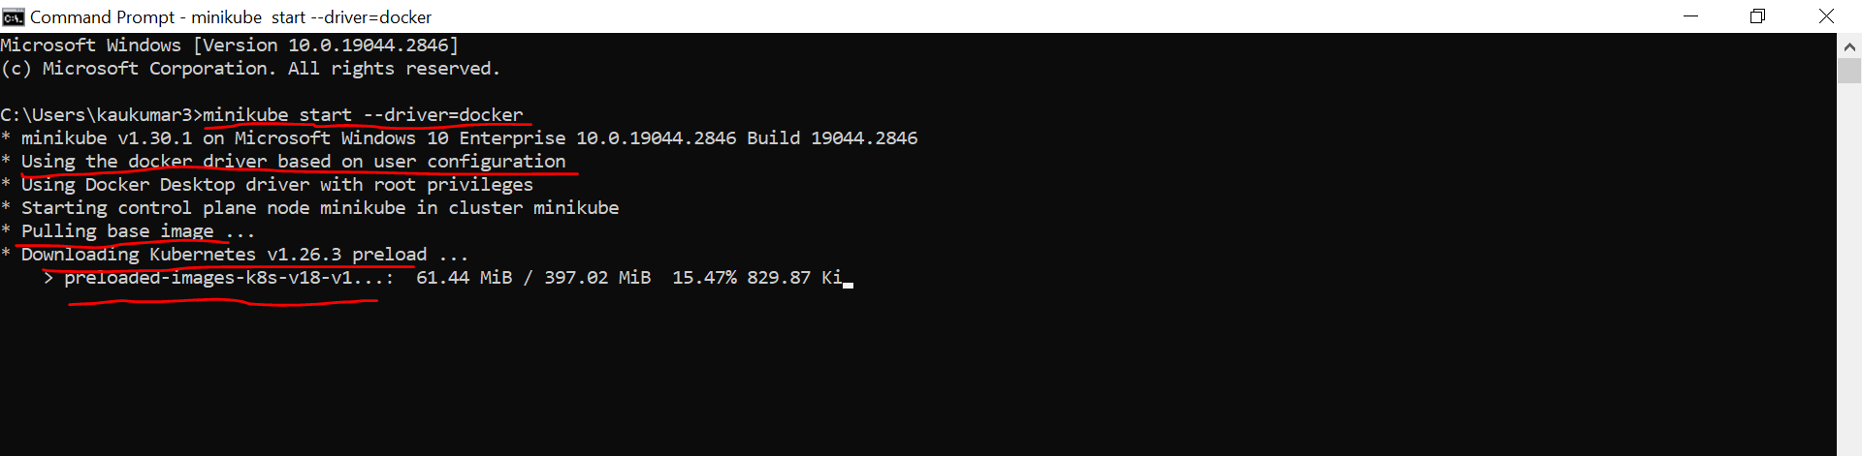

It will take few seconds or few minutes to start the Minikube. Minikube for me, it took 2 to 3 minutes when I tried it before. So, let's wait it to complete. If you observe here, preparing Kubernetes, this is what the version. Okay. On Docker 23.0.5, this is my Docker version. Okay. So, it almost took more than 3 minutes. Let's wait it to complete. So, if you observe, done. Kubectl is now configured to use Minikube cluster and default namespace by default. So, it took around 4.5 minutes for me to start this particular Minikube.

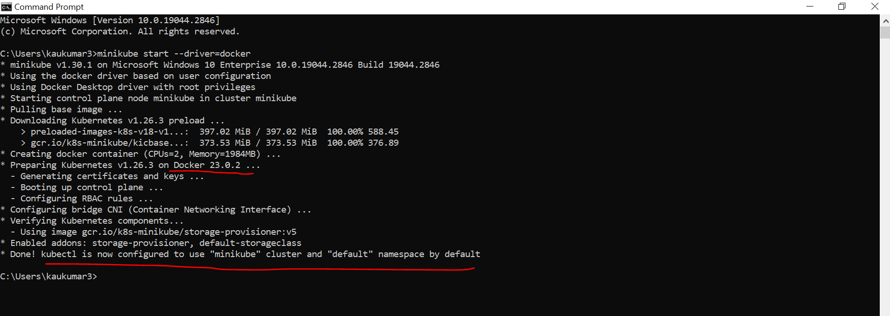

Now to verify Minikube started successfully, you can check Minikube status. Just enter it.

**-> minikube status**

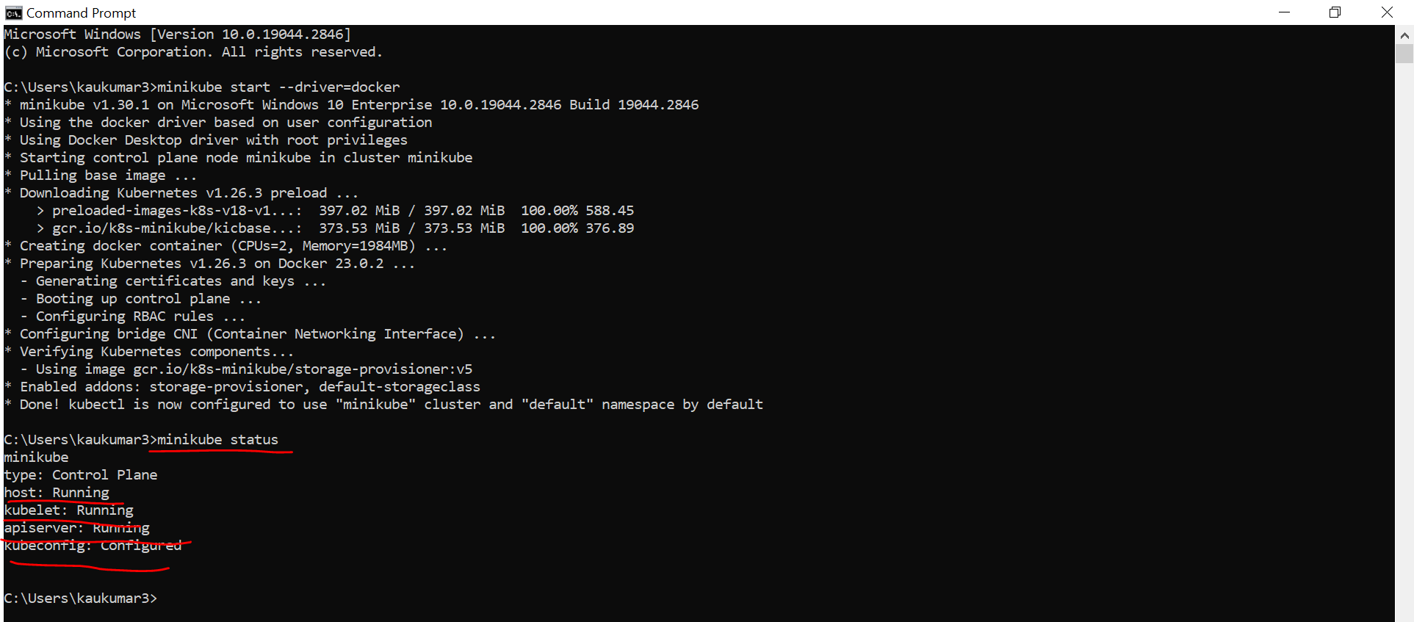

You can see here, host running, Kubelet running, API server running and kubeconfig configured. You should see this status. Okay. Then you can confirm that your Minikube started successfully without having any error or any issue. So, we are good here. We started the Minikube. Now as per the documentation, we understand once we start the Minikube, it will just create a single node cluster, right?

So, you can fire a command kubectl get node. You can see here, the name of the node is Minikube. Status is ready.

**-> kubectl get node**

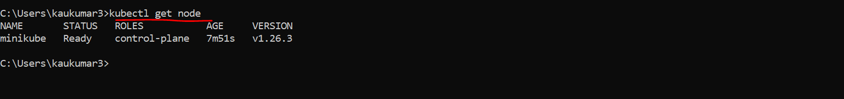

These are the roles and age. These are the version. So as per the Minikube documentation, it just provides us a single node cluster. This is what the node and this is what the cluster. Now we are done with our setup, Kubernetes setup in our local machine.

Now we are good to go with the deployment. Okay, so let's quickly create a Spring Boot project to deploy that to the Kubernetes cluster. Now let me go to my IntelliJ IDEA. Already created one small hello world kind of example where I have only one endpoint and I'm just exposing a string message here. Okay, congratulations successfully deployed your application to Kubernetes.

Application - springboot-k8s-example

Dependency - Spring Web

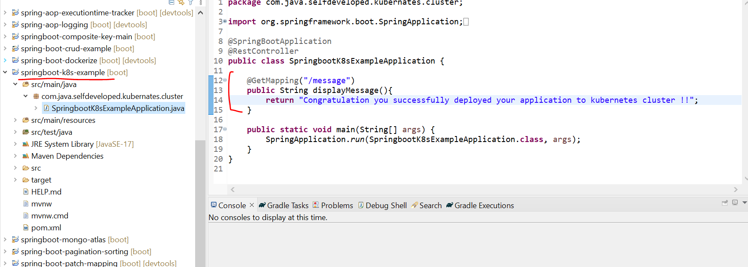

And also, If you observe, I just created a Docker file. Now the first step, I need to dockerize this particular application. Then from the Docker repo, I just need to pull this image and I just need to run it inside Kubernetes cluster. So first I need to dockerize this application.

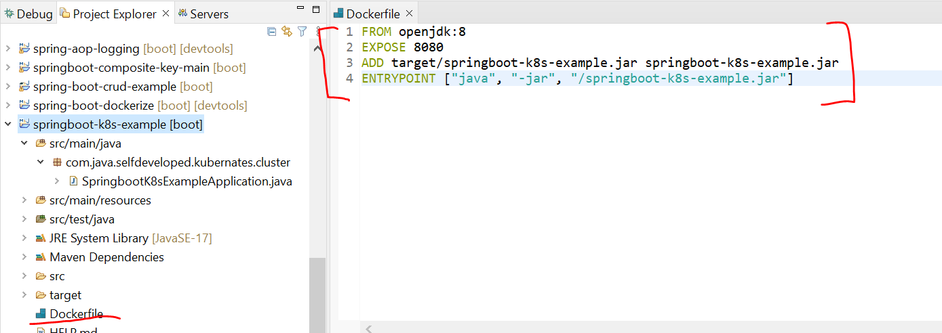

So, to allow Kubernetes to read your Docker repository, we need to run a command. We just need to fire a command Minikube and tell the environment which I am using. Okay, just enter it. Next just copy the last one and just add it, then execute it. Now Kubernetes can read your local Docker repository. Now if I type Docker images, you can see these images specific to the Kubernetes.

* **minikube docker-env**

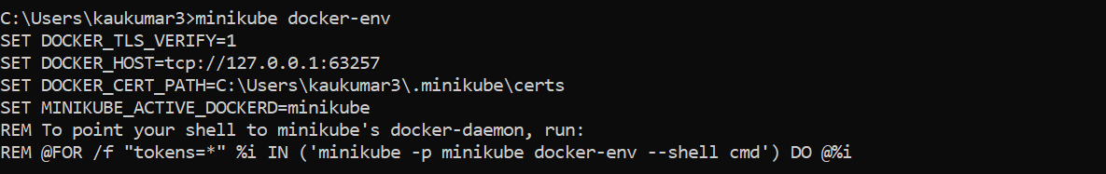

C:\Users\kaukumar3>@FOR /f "tokens=*" %i IN ('minikube -p minikube docker-env --shell cmd') DO @%i

C:\Users\kaukumar3>docker images

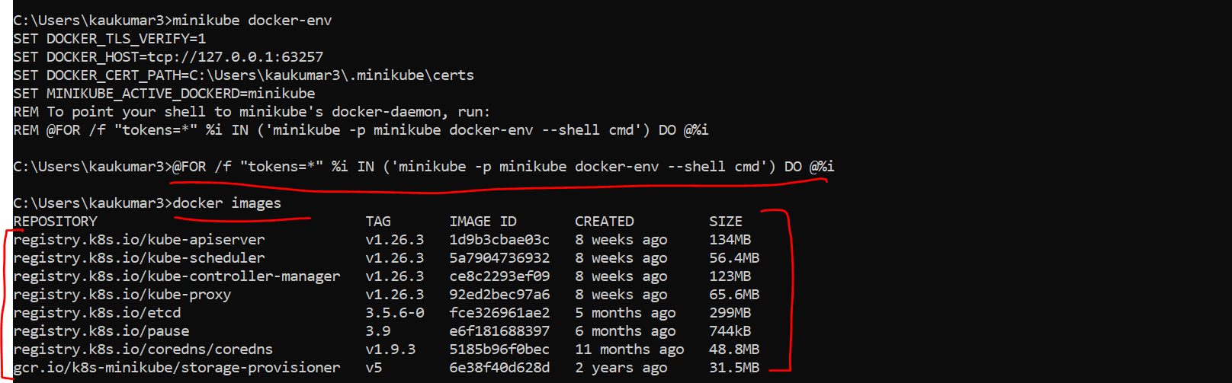

**Below are the master Node Key Components**

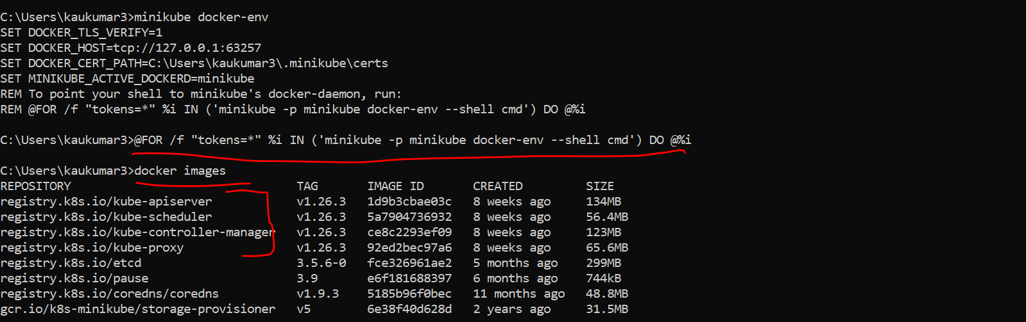

Kube proxy, Kube API server, Kube scheduler, Kube controller manager. These are the master node components, right? Then Kubernetes UI dashboard, etcd, matrix scrapper, something. There is a lot of Kubernetes images, right? Now we give permission to Kubernetes to read my Docker repository. Now we can create the Docker image of our application. So, what I'll do, I'll just move to the particular directory where I have this Docker. So, I'll just copy the path here. From here I can directly move to that particular directory. Okay, let me clear everything. Now I just need to build a Docker image of this particular application spring boot K8s demo and we have the Docker file here, right? This is the Docker file. Now let me go to the command prompt. So here **I'll just type Docker build-t then give the image name. So, I'll just give spring boot K8s demo or something like that. And I'll just specify the version 1.0 and root directory. Just enter it. It will take few seconds. It is creating the Docker image.** Yeah, so if you observe, it created the Docker image. Now to verify that you can type Docker images and you can see this image, right?

C:\Users\kaukumar3>cd C:\Happy Coding_5\springboot-k8s-example

~~C:\Happy Coding_5\springboot-k8s-example> docker build -t springboot-k8s-example:1.0~~

The above command didn’t worked for creating docker images so I tried below one which got worked

**To create the docker image we need to write the docker command**

**C:\Happy Coding_5\springboot-k8s-example>docker build -t springboot-k8s-example .**

For above one we need to add jar name

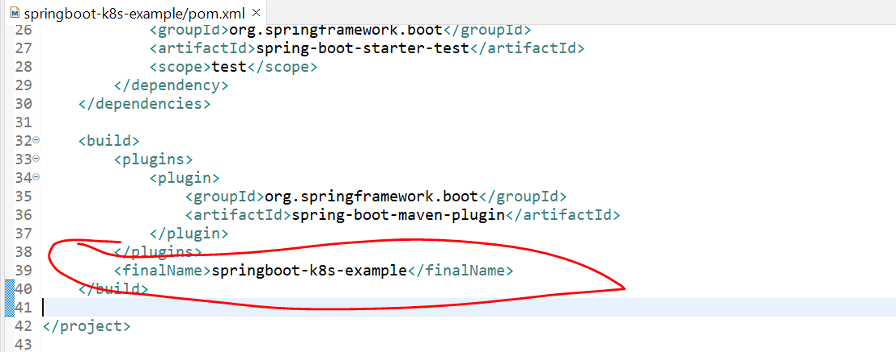

Then Run AS -> maven Install

Then **C:\Happy Coding_5\springboot-k8s-example>docker build -t springboot-k8s-example .**

To verify docker Images

**C:\Happy Coding_5\springboot-k8s-example>docker images**

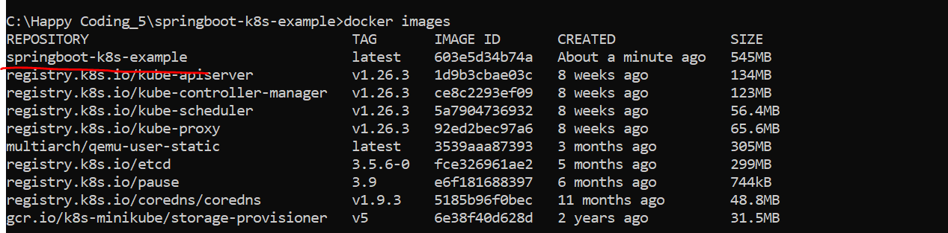

so, we have the spring boot image with us. Now we just want to run this particular image inside the pod, right? So, for that you need to create a deployment object. As you know, deployments are Kubernetes object that are used for managing the pods. We can describe deployment object details using YML file or you can directly use the command prompt. For this example, I will just use the command prompt. In my next tutorial, I will show you how you can create the deployment and service with the help of YML configuration. Okay, now let's quickly create a deployment object using t using the command prompt.he command prompt.

C:\Happy Coding_5\springboot-k8s-example>kubectl create deployment spring-boot-k8s --image=springboot-k8s-example --port=8080



So, I can directly type the command, kubectl. Okay, then create deployment, give the name of your deployment. So, I'll just give spring boot k8s. Okay, and just tell Kubernetes to read your image, which is the Docker image, right? So I can just specify image, give the name of your image, which is spring boot k8s example paste it right? And then specify the port, which is 8080. So, with the above command, we are telling to Kubernetes create a deployment with name spring boot k8s. Okay, and then read the Docker image, which is spring boot k8s example And run this inside a pod. Okay, so just enter it, it will create a deployment for you. So, you can see here deployment.apps spring boot k8s created. This is what my deployment object created.

C:\Happy Coding_5\springboot-k8s-example>kubectl get deployment

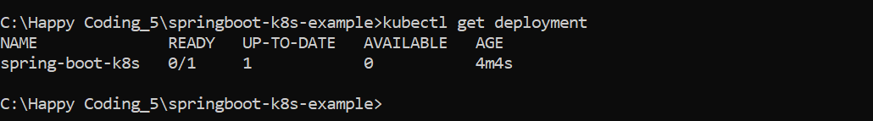

**C:\Happy Coding_5\springboot-k8s-example>kubectl describe deployment spring-boot-k8s**

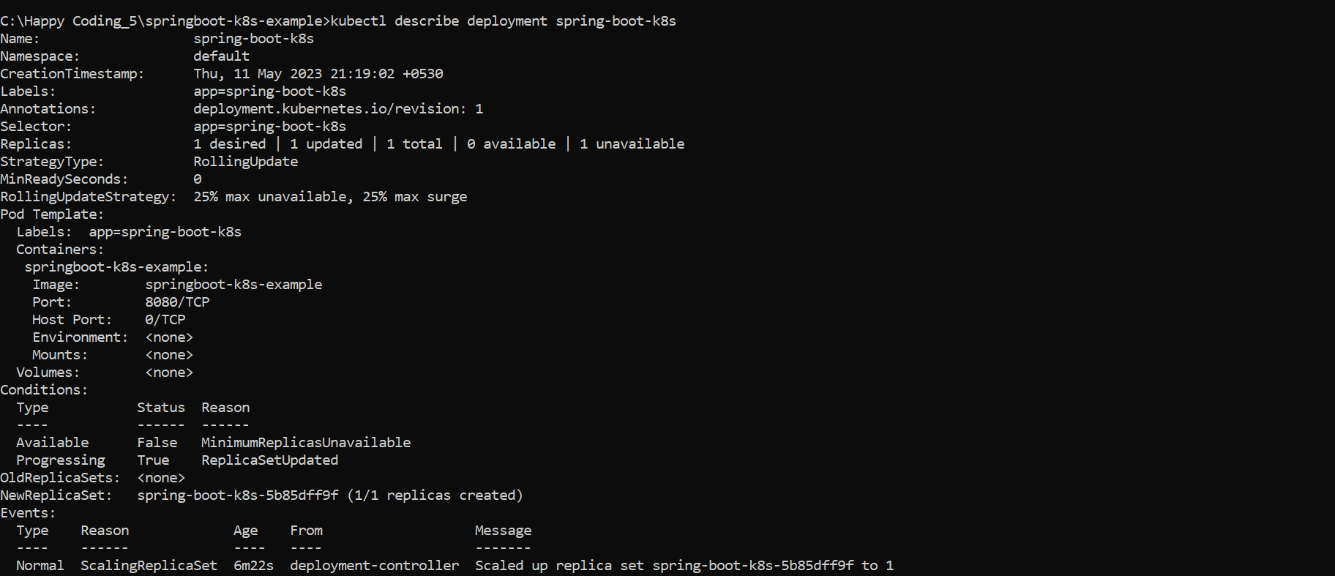

Now let me zoom this. Let's verify the deployments. Okay, so you can type kubectl get deployment. You can observe here, this is the name of the deployment and the status you can see it's in ready state. Okay, one by one, and up to date one available one, this is what the age fine. Now you can describe your deployments, you can see all the replicas and everything all the description about your deployment. So, you can just type kubectl get deployment description or kubectl describe deployment and give the name of your deployment, which is spring boot k8s. So, you can see, this is what the description of your deployment. You can see here right, new replica set one by one replica set was created because you didn't specify the replicas. And then this is what the deployment controller scaled of replica sets spring boot. This is what the pod you can say, okay, I'll show you the pod as well. Now to ensure that Kubernetes successfully pull my Docker image and run it inside a pods, we can execute a below command, kubectl get pods, you can check the status of your pods, just enter it.

**C:\Happy Coding_5\springboot-k8s-example>kubectl get pods**



**C:\Happy Coding_5\springboot-k8s-example>kubectl get deployment**

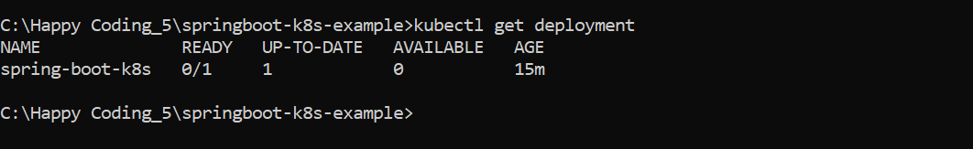

**C:\Happy Coding_5\springboot-k8s-example>kubectl expose deployment spring-boot-k8s --type=NodePort**

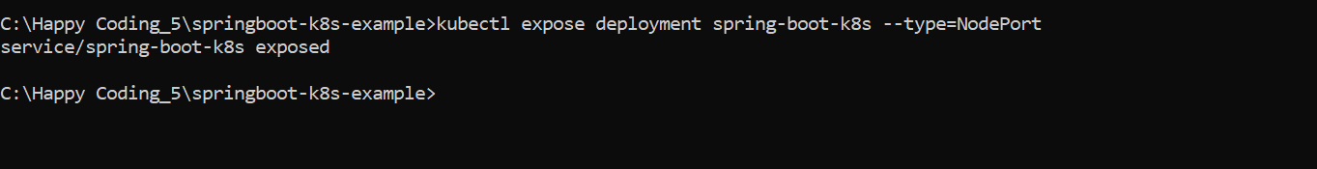

**C:\Happy Coding_5\springboot-k8s-example>kubectl get service**

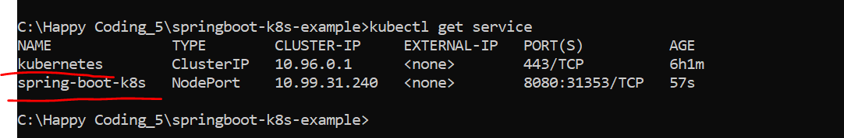

**C:\Happy Coding_5\springboot-k8s-example>minikube service spring-boot-k8s –url**

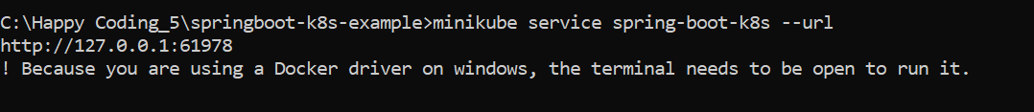

[**http://127.0.0.1:61978/message/**](http://127.0.0.1:61978/message/)

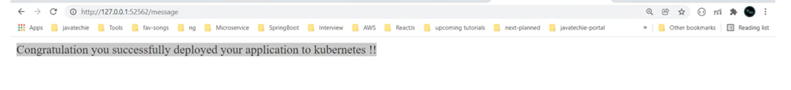

**C:\Happy Coding_5\springboot-k8s-example>minikube dashboard**

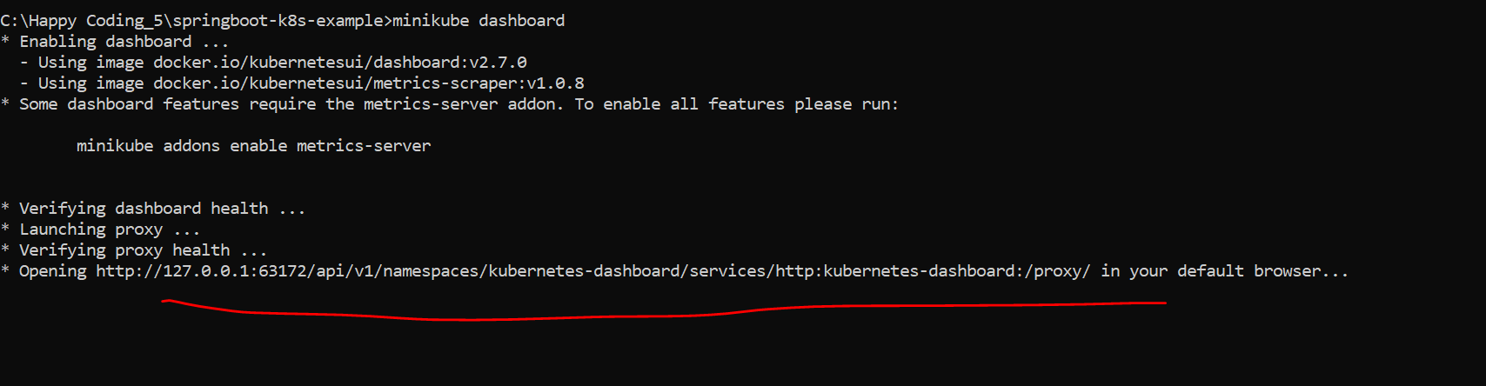

[Kubernetes Dashboard](http://127.0.0.1:63172/api/v1/namespaces/kubernetes-dashboard/services/http:kubernetes-dashboard:/proxy/#/workloads?namespace=default)

<http://127.0.0.1:63172/api/v1/namespaces/kubernetes-dashboard/services/http:kubernetes-dashboard:/proxy/>

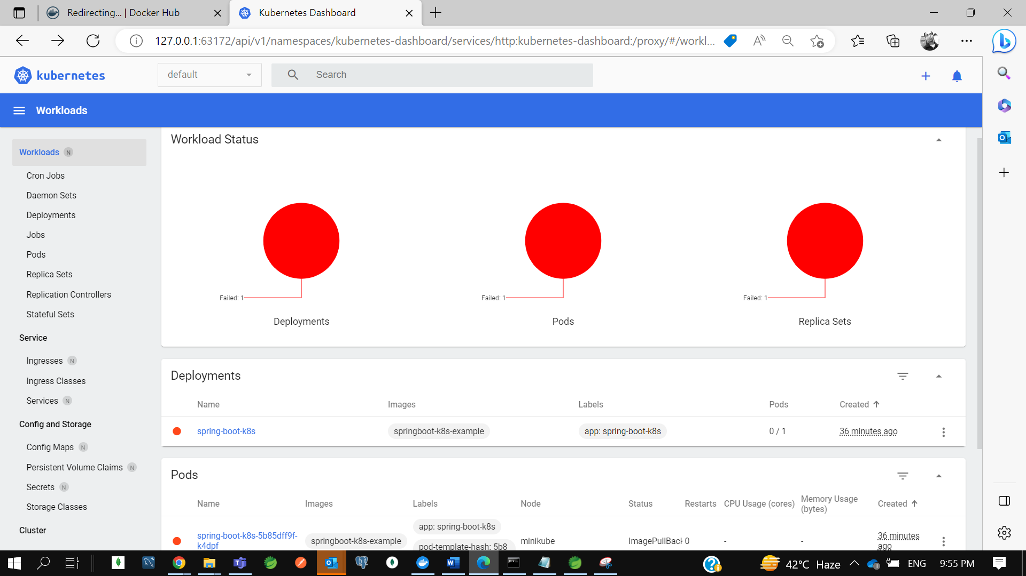

C:\Happy Coding_5\springboot-k8s-example>kubectl delete service spring-boot-k8s

service "spring-boot-k8s" deleted

C:\Happy Coding_5\springboot-k8s-example>kubectl delete deployment spring-boot-k8s

deployment.apps "spring-boot-k8s" deleted

C:\Happy Coding_5\springboot-k8s-example>kubectl get pods

No resources found in default namespace.

C:\Happy Coding_5\springboot-k8s-example>kubectl get service

NAME TYPE CLUSTER-IP EXTERNAL-IP PORT(S) AGE

kubernetes ClusterIP 10.96.0.1 <none> 443/TCP 6h24m

C:\Happy Coding_5\springboot-k8s-example>kubectl get deployment

No resources found in default namespace.

C:\Happy Coding_5\springboot-k8s-example>minikube stop

* Stopping node "minikube" ...

* Powering off "minikube" via SSH ...

* 1 node stopped.

C:\Happy Coding_5\springboot-k8s-example>minikube delete

* Deleting "minikube" in docker ...

* Deleting container "minikube" ...

* Removing C:\Users\kaukumar3\.minikube\machines\minikube ...

* Removed all traces of the "minikube" cluster.

C:\Happy Coding_5\springboot-k8s-example>

* **Kubernetes Tutorial | Run & Deploy Spring Boot Application in K8s Cluster using yaml configuration**

(How to create **Deployment Object** & **Service Object**)

In previous tutorial we learned how to deploy our springboot application on Kubernates cluster using **kubectl** command

In this we will deploy the same application to Kubernates cluster but instead of using kubectl command we will use **yaml** configuration to create deployment and service object of Kubernates.

Let’s create a spring boot application ---

App name- **springboot-k8s-application**

Let’s create a docker image of this spring boot application. There are multiple way either we can use **google jib** **library**, or you can use the **build pack of spring boot**, or **u can use maven plugin**…I will use traditional approach with creating a Dockerfile.

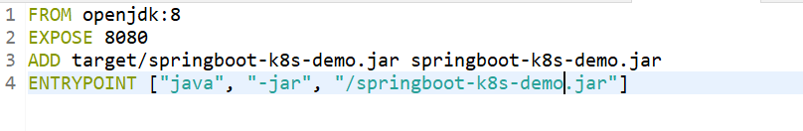

Now first step we need to start the minikube. Then you need to allow Kubernates to read your local docker repository.

So first you need to start the minikube. just type one command. to verify minikube started type minikube status.

**++ minikube version**

**++ minikube start or minikube start --driver=docker**

**++ minikube status**

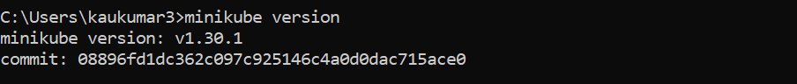

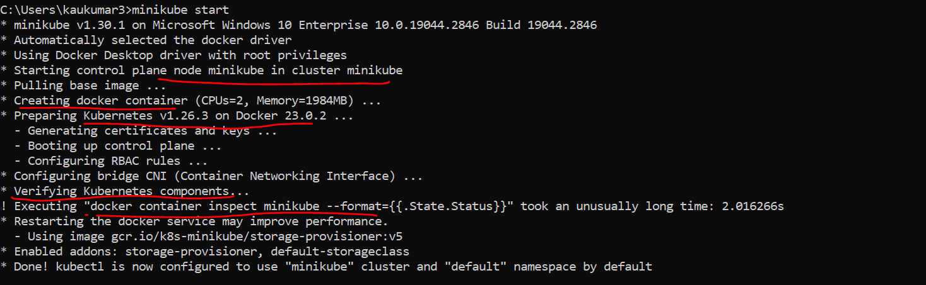

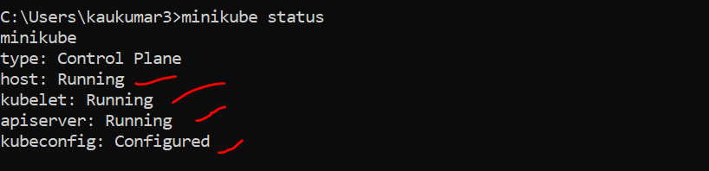

Now we need to allow Kubernates to read our docker repository. so, for that we need to fire a command

**++ minikube docker-env**

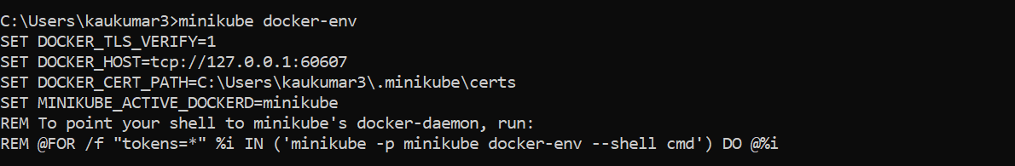

So, to allow Kubernetes to read your Docker repository, we need to run a command. We just need to fire a command Minikube and tell the environment which I am using. Okay, just enter it. Next just copy the last one and just add it, then execute it. Now Kubernetes can read your local Docker repository. Now if I type Docker images, you can see these images specific to the Kubernetes.

**C:\Users\kaukumar3>@FOR /f "tokens=*" %i IN ('minikube -p minikube docker-env --shell cmd') DO @%i**

**C:\Users\kaukumar3>docker images**

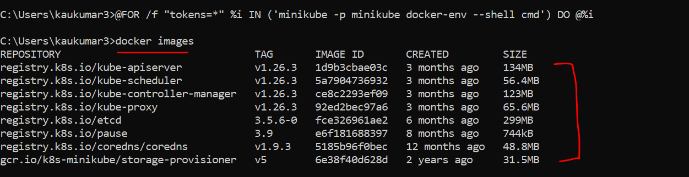

Below are the master Node Key Components

Now you need to go to project directory to create a docker image.

**++ cd C:\Happy Coding_5\springboot-k8s-application**

Now inside this particular directory I have a Dockerfile you can verify that.

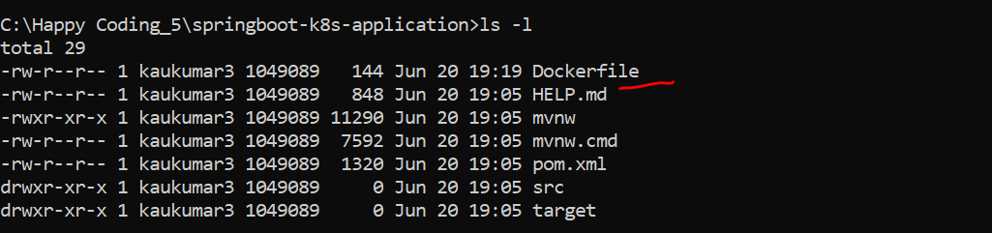

**++ docker build -t springboot-k8s-demo:1.0 .**

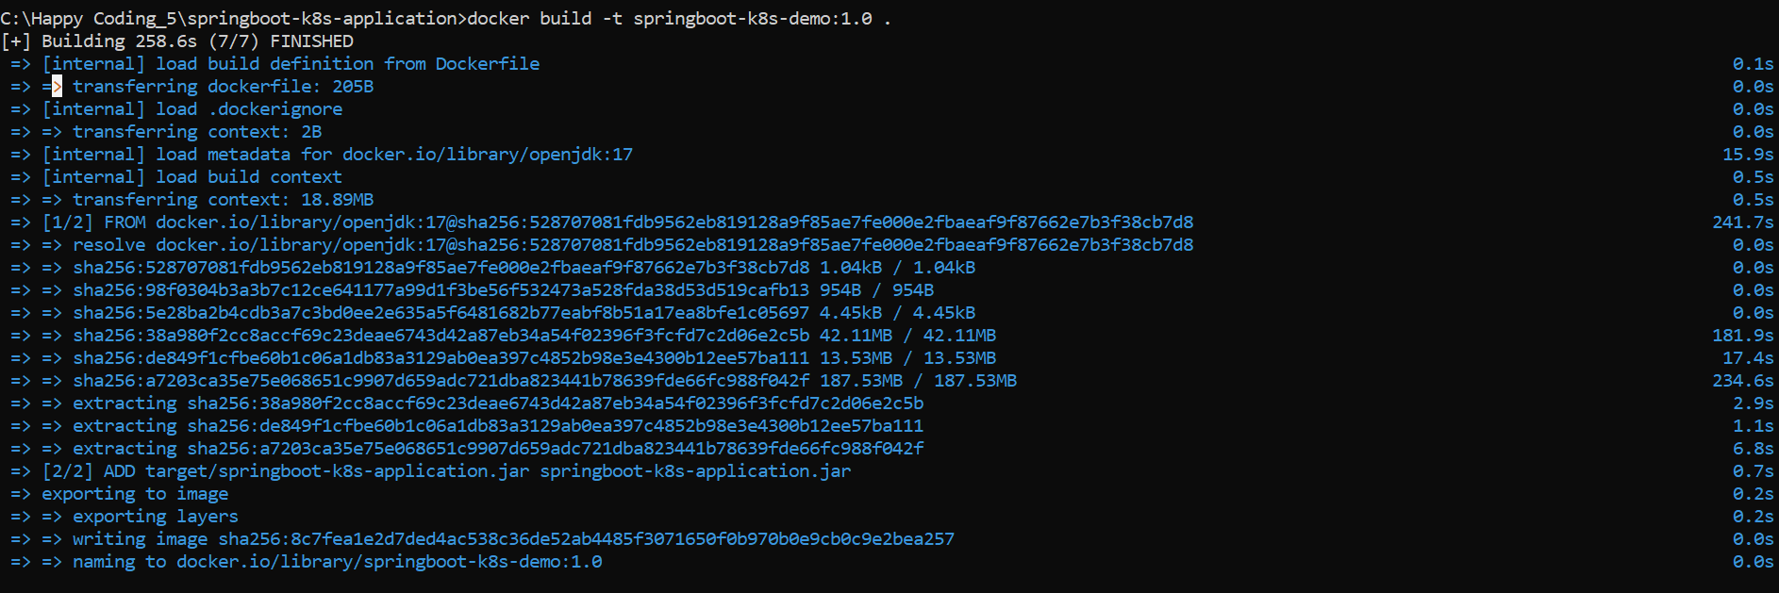

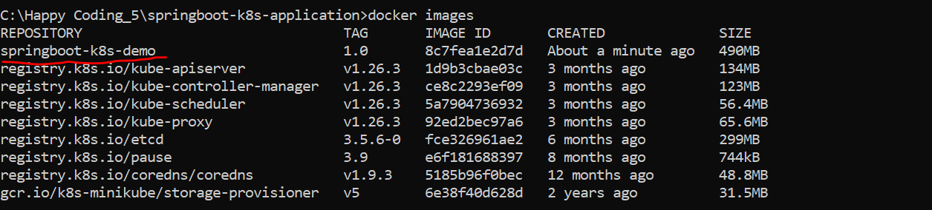

So, we can see our image now.

* **Steps to Create a Deployment Object**

Now we need to deploy this particular docker image to Kubernates cluster. So, deploy this docker image to Kubernates cluster we need to create a deployment object. If u remember earlier tutorial, we have created deployment object using kubectl command. now the best way to make this deployment in Kubernates is by preparing yml file which is industry standard. By configuring this yml file or by creating this deployment yml file we are telling to Kubernates to create an instance of my spring boot application in Kubernates cluster.

Or we are telling to Kubernates just create a spring boot image in my Kubernates pod and just run it inside some container. So that’s what we need to describe as part of the deployment file.

File- **k8s-deployment.yaml**

Now here u need to give all the info so that Kubernates can read that and he will run your particular application to the Kubernates cluster.

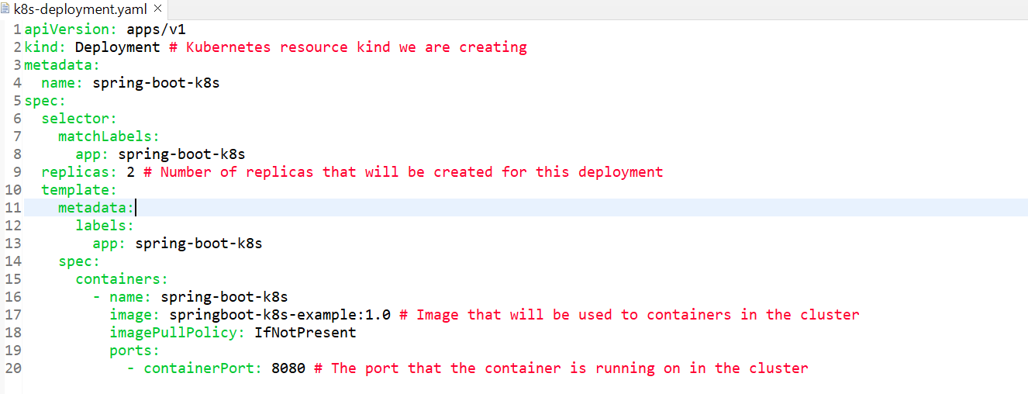

* Api versions describe version of ur api server
* Kind is nothing I am telling Kubernates the type of object I am creating. For deployment we mentioned deployment and for service we need to mentioned service.
* Metadata give info about the application name and labels you can give any name.
* There is a key called spec inside that there is a selector and labels.
* You can group multiple pods inside a single service so that’s the reason we are using selector and labels. As of now just understand this selector and label should be same as in deployment and service object.
* There is something called replica we are just telling to Kubernates create 2 pods of my application in Kubernates cluster. If u want 4 u can just mentioned here.
* Now inside the spec you just define the container and you are telling to Kubernates this is what my name of my container this is what the image you need to fetch it from my docker repo
* We specify Image pull policy : if not present. If u not specify image pull policy Kubernates search image in docker hub, so if u specify it will see first in ur local if not present then pull from docker hub.
* Now there is a port. So, container port is 8080. The port that the container is running on cluster.
* This is what all info u need to provide as part of deployment object.

Now to create this deployment object what u need to do go to terminal.

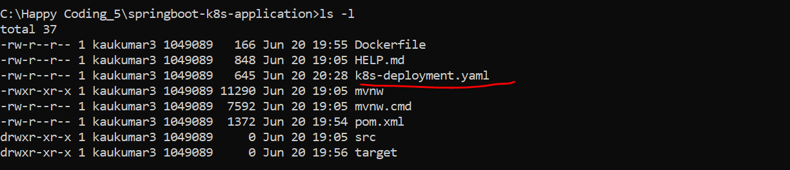

**++ kubectl apply -f k8s-deployment.yaml**



So, you can see it created the deployment object. -f is the file specified

**++ kubectl get deployments**

Now to verify that we can use command kubectl get deployments

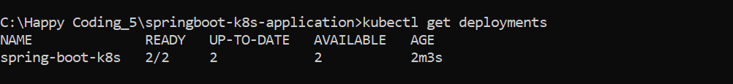

So, u can see there are 2 pods running in our application bcz we created replica of 2.thats the reason u can see 2 instance.

**++ kubectl get pods**

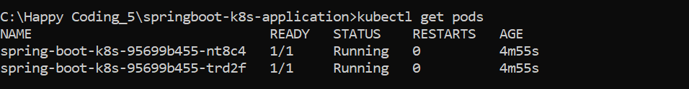

So, there is 2 pods running which means for a single application there is 2 separate instance running in 3 diff pods with diff Ip Address.

So, u can also verify whether ur pods is running successful or not by checking the log of ur pod.

**++kubectl logs spring-boot-k8s-95699b455-nt8c4**

**++kubectl logs spring-boot-k8s-95699b455-trd2f**

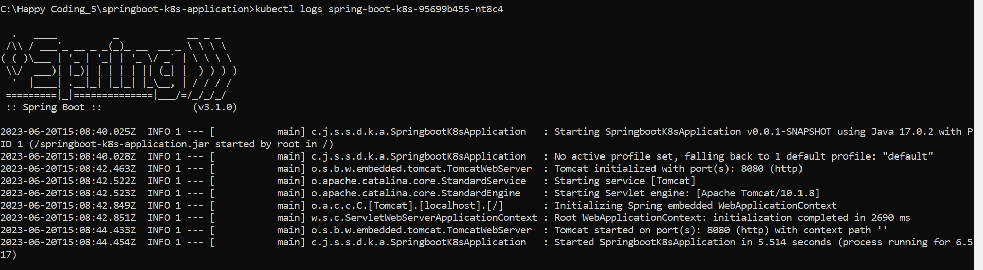

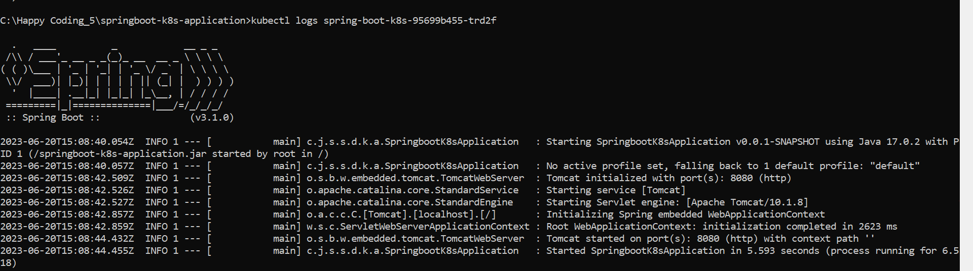

Now our application is running smoothly in our Kubernates cluster on port 8080. But we have a challenge here if u observe my application is running here on 3 different pods. I mean in 3 diff instances. So, there is 2 instances of my application.

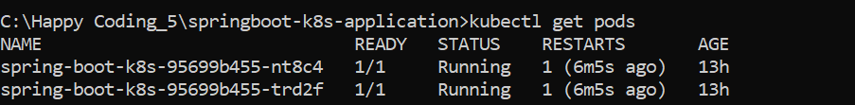

* Now the challenge here how can I consume my application. If I send request to access my application where does my request will land whether it will go to first pod or second pods, we don’t know and how Kubernates also knows whether to send the request since there is 2 different instances. Now to solve this kind of challenge we need some load balancer mechanism. That’s why Kubernates provides us a specific component called services.
* In Kubernates **Service** plays a role of service discovery where it exposes our application to outside the world or to outside the Kubernates cluster as well as it act as a load balancer where it decides which pods should handle the request.
* If a user sends a request to an application since there is 3 instances is running Kubernates service will be decide to whom he need to send the particular request. Whether it is pod1 , pod2 or may be pod 3 if there based on the load availability. that’s the reason there is a separate component which is service object.
* **Steps to Create a Service Object**

Let’s create a **service. Yaml** file.

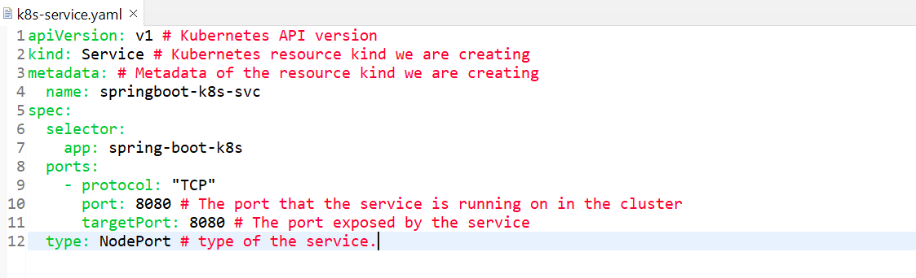

I am just giving api version which is nothing v1. As a kind I am telling this is kind a service component object. As a metadata you can give any name to your service and then spec selector, this selector name should be same as your deployment selector. Next is port and protocol which TCP and port 8080. This port that the service is running on Kubernates cluster. Again, u need to provide the target port the port exposed by the service. this is the last key type which u need to remember this is type of service. so, here i am just using type as a **NodePort.** It means I can able to access my api with the help of node Ip and Node port. So, there are a 3 type services like **Cluster IP, Load Balancer and NodePort** available in Kubernates cluster**.**

In this app we are using Node Port service, so we are able to access our application using node Ip and port.

Now we created our service file. Now let’s expose our app to outside Kubernates cluster. We just need to expose this particular service.

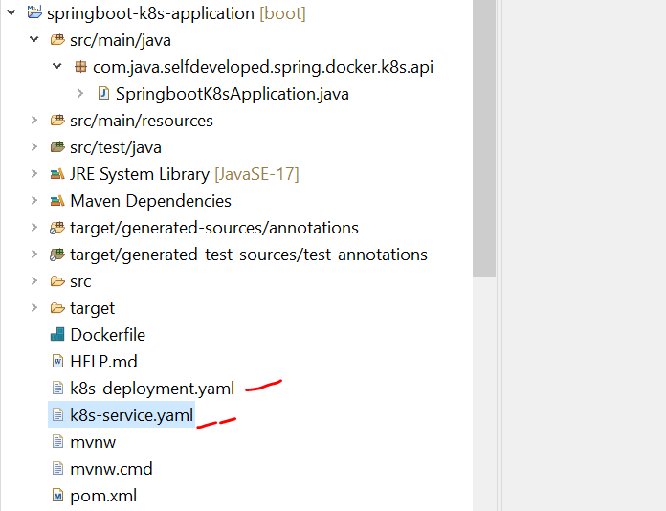

**++ kubectl apply -f k8s-service.yaml**



If u observed, it created the service.

**++ kubectl get service or kubectl get svc**

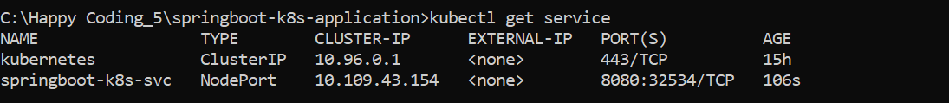

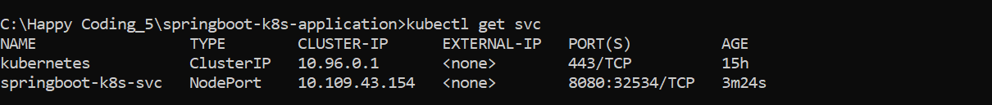

So, this is the service type is node port and ip address is 10.109.43.154 and post is 32534 with the help of this u are able to access api.

Now to verify the node ip

**++ kubectl get nodes -o wide**



If u observed this is **192.168.49.2** what the ip address and this is **32534/TCP** what the port with the help of that we can able to access the endpoint which is hosted in Kubernates cluster.

Now since we have exposed our service as a node port , so we need node ip and node port to access the api.







So, we successfully hosted our application to Kubernates cluster using yaml configuration of deployment and service project. now let’s check the status of each component in our Kubernates dashboard.

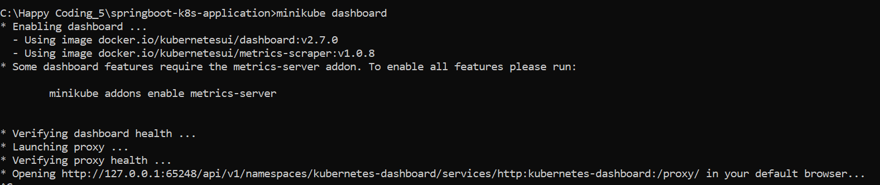

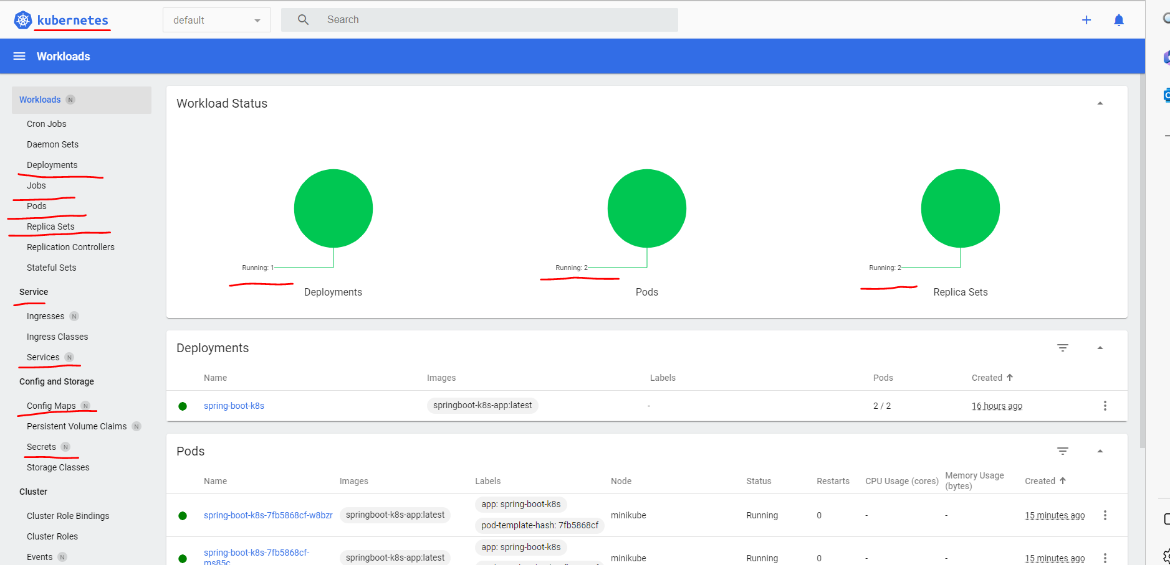

So u can see there are 2 pods it’s running bcz we have created a replica set of 2.

So u can see there is 2 pods is running

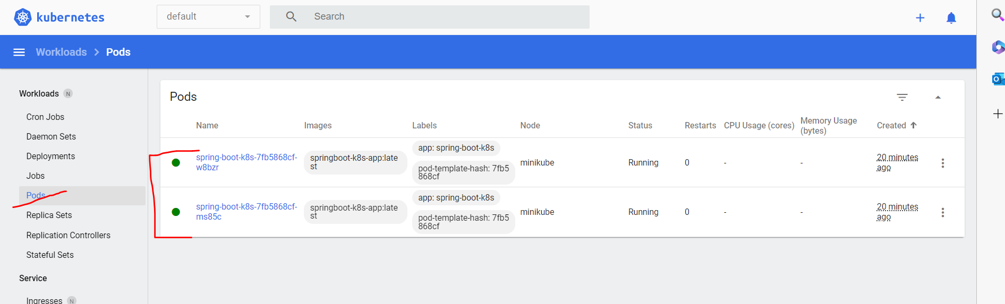

Bcz we have created replica 2. If u delete any pods Kubernates will restart a different pods.

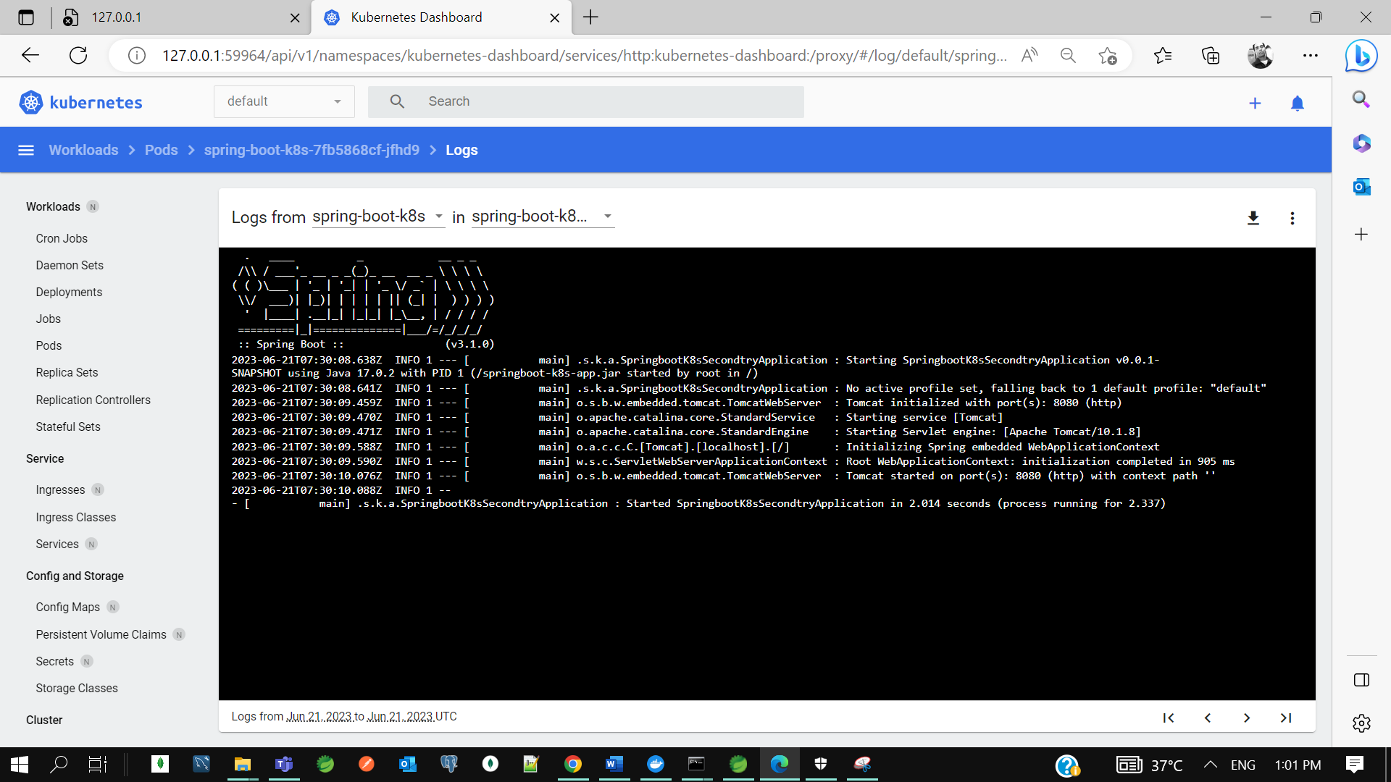

If u want to see the logs of any pods. This is what the concepts of self-healing in Kubernates. While we delete one pod Kubernates will start a new pod for you. If u want u can check other component as well like service and replica set.

* **Kubernetes Tutorial | Run & Deploy Spring Boot CRUD Application with MySQL on K8S**

In last we deployed a simple spring boot application to Kubernates cluster. In this we will understand how we can deploy springboot crud application to Kubernates cluster where we are going to use mysql as a database instance. Let’s recap--

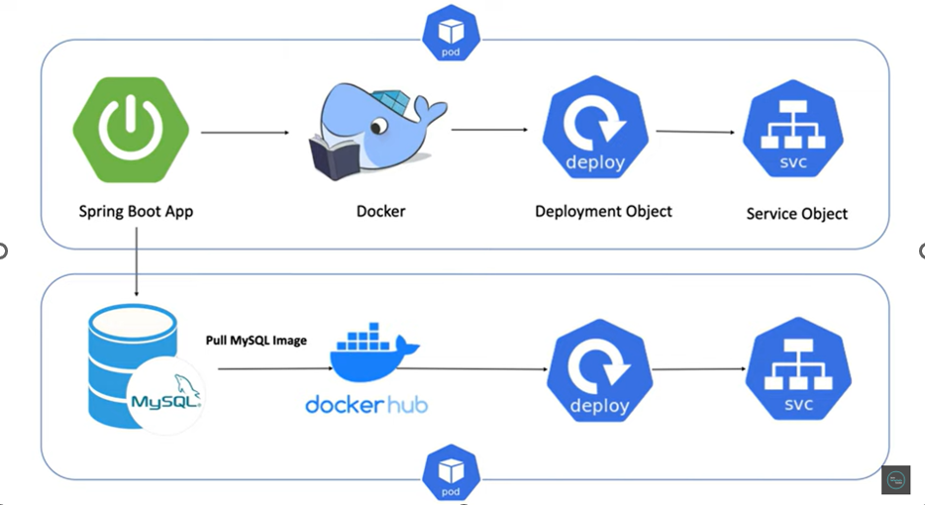

We created a springboot application then we build docker image of our springboot application then we created deployment object using yaml configuration where u tell to Kubernates take this docker image and run it inside Kubernates pods then we created service object with the service object we informed to the Kubernates expose my application to outside this Kubernates cluster. So that user can able to access it. These are the basics steps if we want to deploy our app to Kubernates cluster.

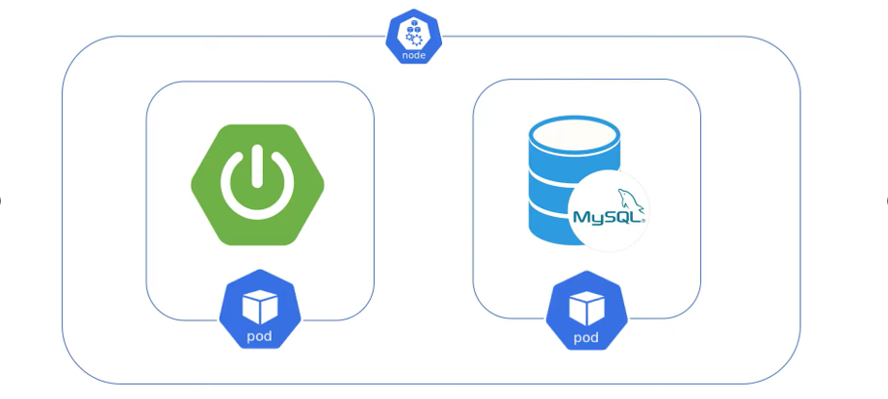

Now in our application we are going to integrate MySQL database. now here we need to run database instance in different pods inside Kubernates cluster. So, what we ll do the way we deployed our spring boot app to Kubernates similar steps we need to follow for database instance as well.

So, first step we need to pull mysql image from docker hub. Then you need to create the deployment object and tell Kubernates to take my sql image and run it inside a separate pod. Then you can create a service object so that you can expose your db instance outside to the Kubernates cluster so that your spring boot application can connect to the mysql db instance.



Now if u see at high level, then inside a Node there will be 2 pods one pod will run our spring boot application and another pod will run our my sql instance.

Let’s create a spring boot crud application with pom dependencies, all rest point and db configuration.

Let’s first test our application in local.

Application - **springboot-crud-k8s-app**

Dependencies- web. Lombok. Data jpa, mysql connect driver

We have tested all our endpoint its working fine…

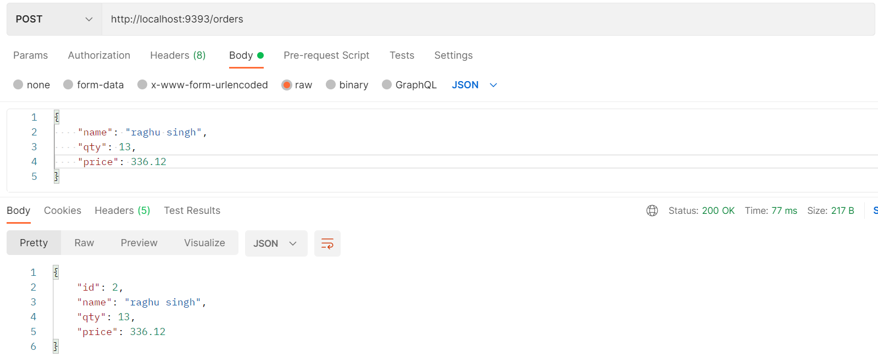

GET <http://localhost:9393/orders>

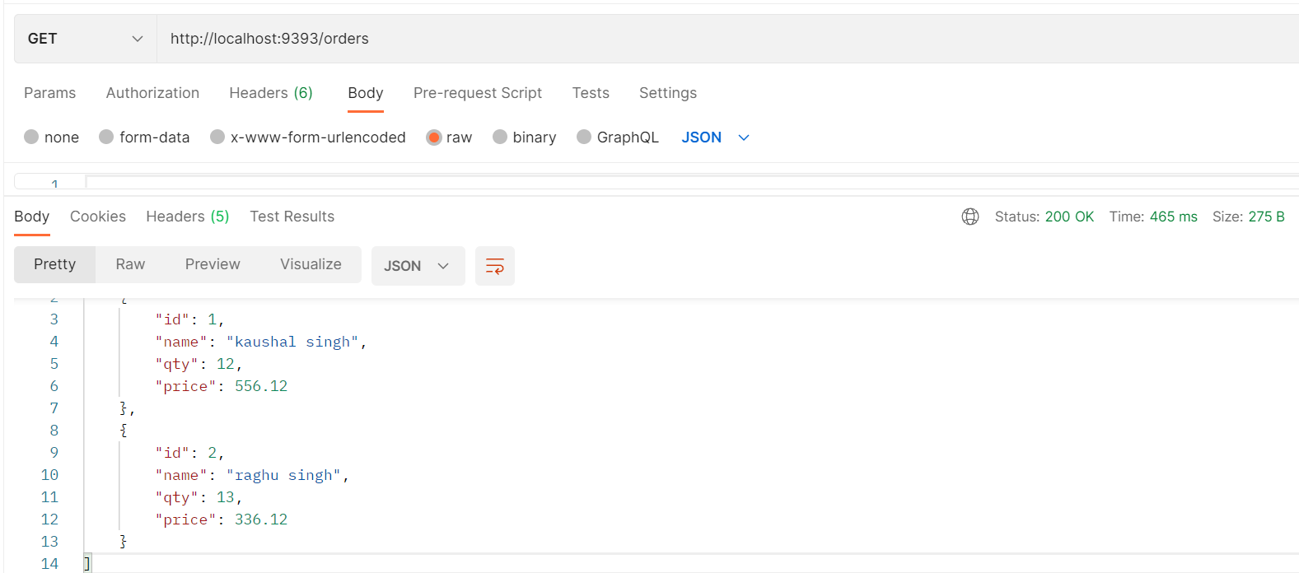

GET <http://localhost:9393/orders/2>

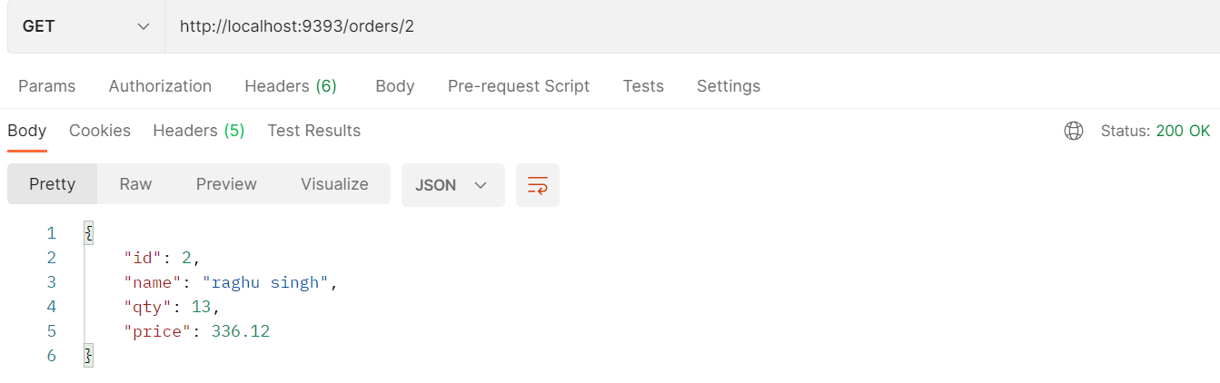

Now let’s dockerize our spring boot crud app using Dockerfile.

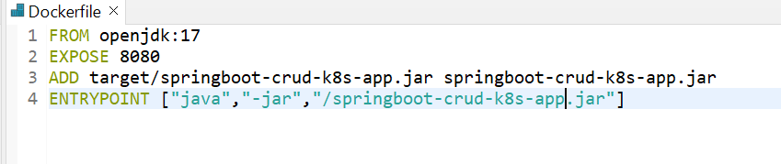

* If u deploy this app it won’t work bcz there are no db instance running in Kubernates cluster. So, my application needs to connect to mysql instance which is running in diff pod in Kubernates cluster.
* So far, we didn’t deploy my sql instance to the Kubernates cluster.
* So first we need to deploy mysql instance to Kubernates pod then we need to deploy my app. Lets pull mysql image from docker hub.

Before that we need to start our minikube. So it will start the Kubernates in my machine. Now I just want to sink both my docker and minikube.

**++ minikube start**

**++ minikube docker-env**

**++ docker images**

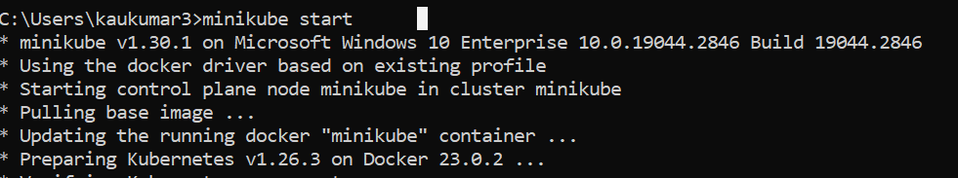

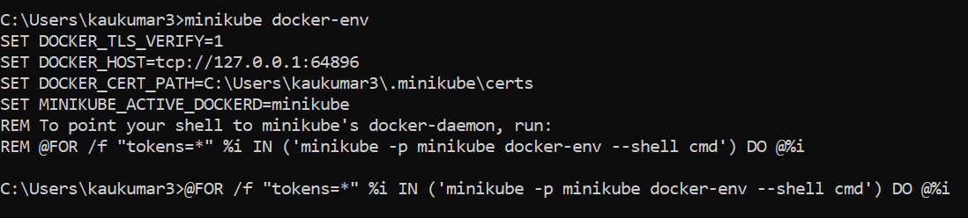

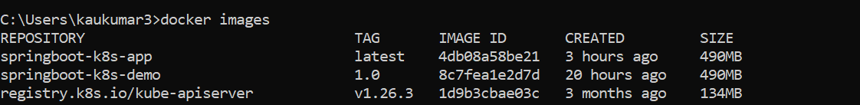

* Now first we need to pull the my sql image from docker hub but we are not going to do it manually. While creating the deployment object we will just specify the latest my sql version so that Kubernates deployment object will take care to pull the mysql image and execute in a separate pod.
* Now we need to create a deployment and service object using yaml configuration.

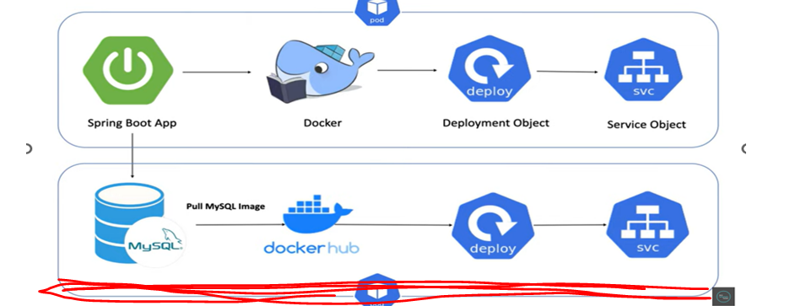

* To create and run a mysql instance in Kubernates pods we need to create a deployment object and to expose that particular instance outside to Kubernates cluster we need to create a service object.

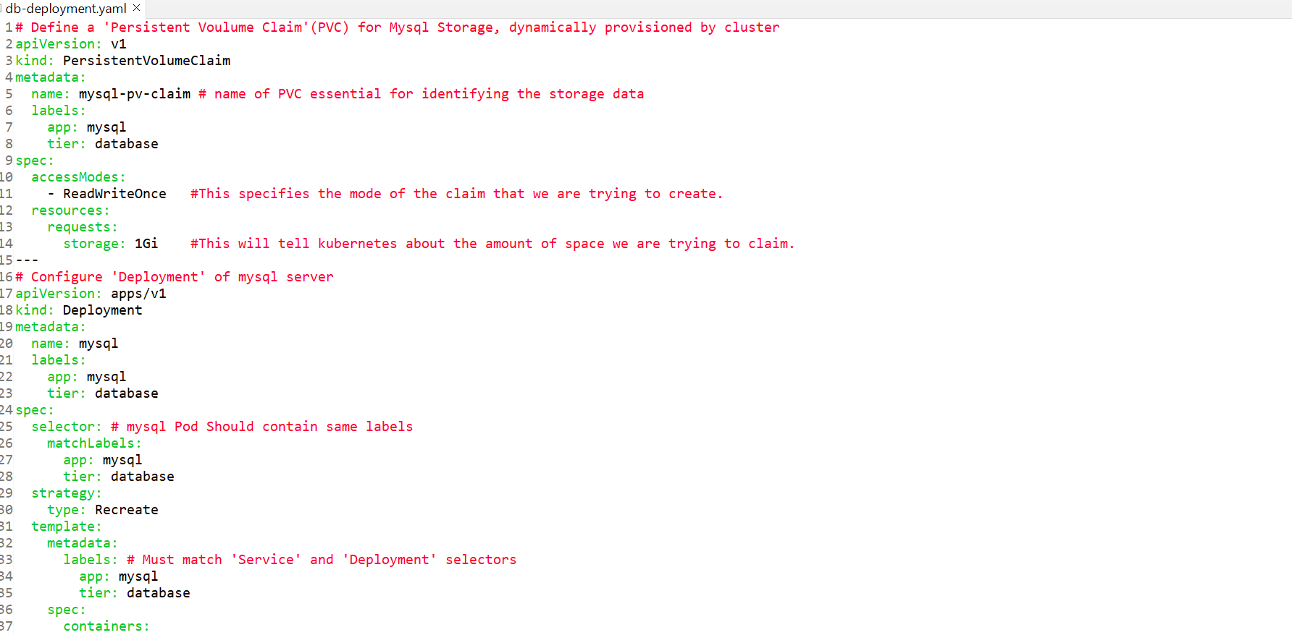

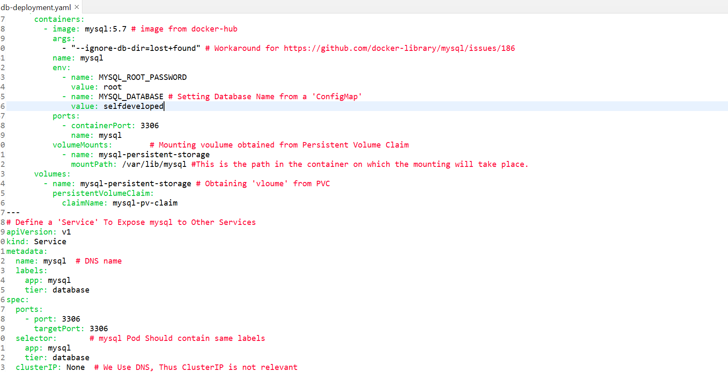

We are creating deployment object of our mysql. And also, we are creating service object of our mysql. Apart from that we are also creating another component which is **PersistenceVolumeClaim**, this will tall Kubernates to get the storage for running your database instance that’s the use of this PersistenceVolumeClaim and we are just specifying the metadata and we are just adding the label and access mode is **READ** & **WRITE**.

If u observe the next component is deployment object and as part of deployment object, we are telling to Kubernates get the latest mysql 5.7 image from the docker hub and just run it inside a Kubernates pod where the root password is root and create a mysql database name **selfdeveloped** and **3306** is what our container port and this is our host which is **mysql**. And we are just persistence our object to PersistenceVolumeClaim with which we created in our first component. This is what the alias I am giving here. that’s what the deployment object which we created for our mysql.

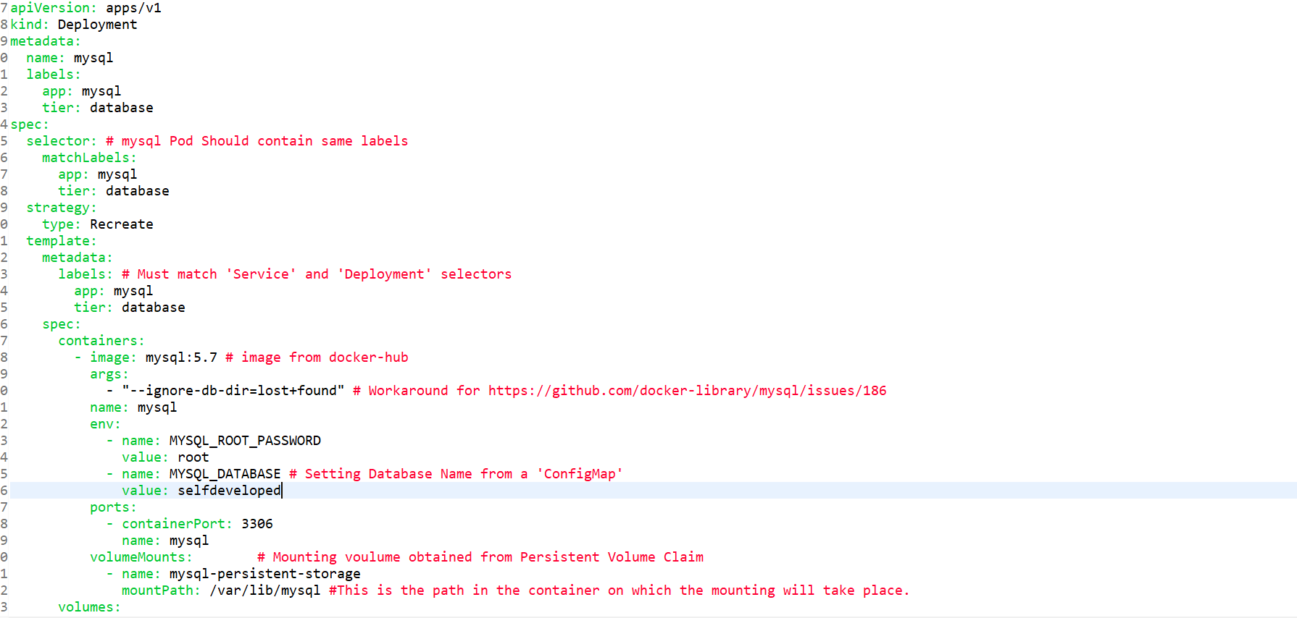

So, this is the entire deployment object we created.

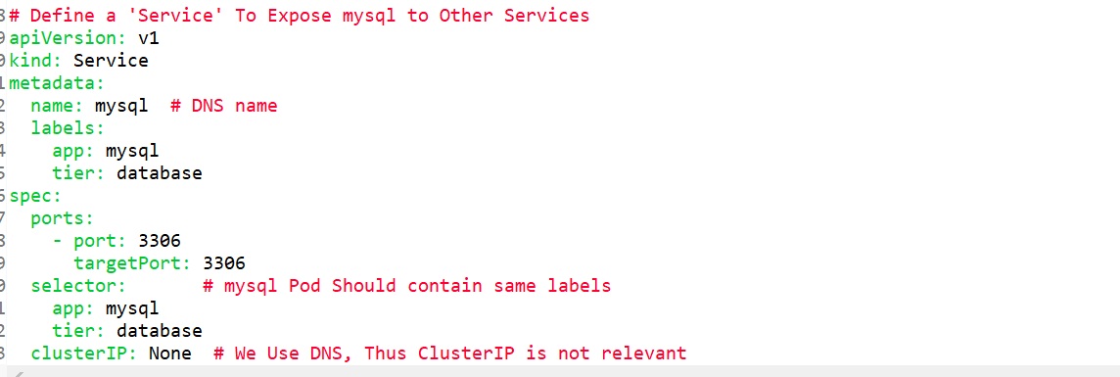

Next as part of service object we are just giving the name of our service which is mysql service. we are just giving our target port 3306. We are not specifying any service type like **NodePort** or **api cluster** or **load balancer**.

** So, no service type specified for a mysql database instance.

Now with this information we can start mysql pod in Kubernates cluster. So, for that I need to go to this particular project directory and need to execute this particular **db-deployment.yaml** configuration.

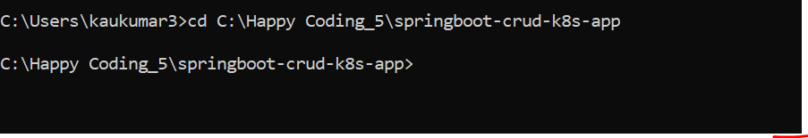

Now here I can execute this particular **db-deployment.yaml** file so that it will create a pod for us so that mysql instance can run over there.

**++ kubectl apply -f db-deployment.yaml**



We can see it created **PersistenVolumeClaim** , it created **deployment** **object** and it also created **service** **object**.

To verify let’s check

++ **kubectl get deployments**

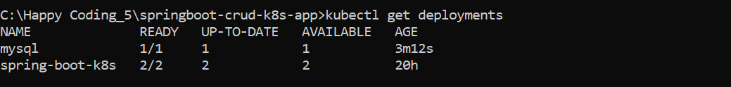

**++ get pods**

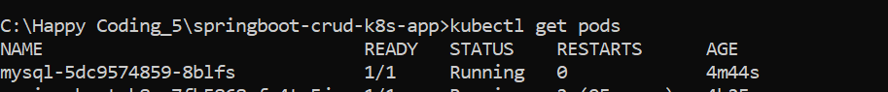

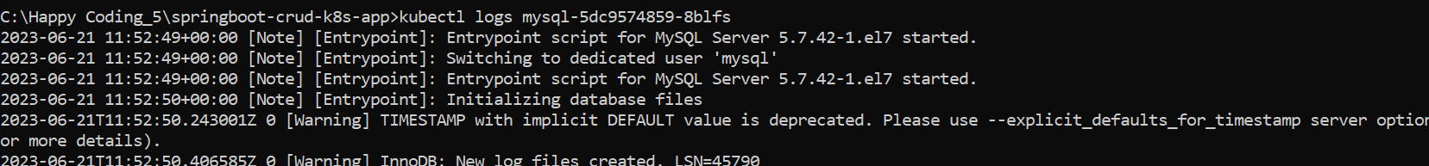

-------------------------------------------just to verify mysql schema---------------------------------------------------

Now we will directly login to mysql pod to check the schema status.

<><> For that lets go to another terminal, now we will go this particular mysql pod and we will verify

**++ kubectl get pods**

**++ kubectl exec -it mysql-5dc9574859-8blfs /bin/bash**

**++ mysql -h mysql -u root -p Enter->(it will ask for pwd so pwd is also root)**

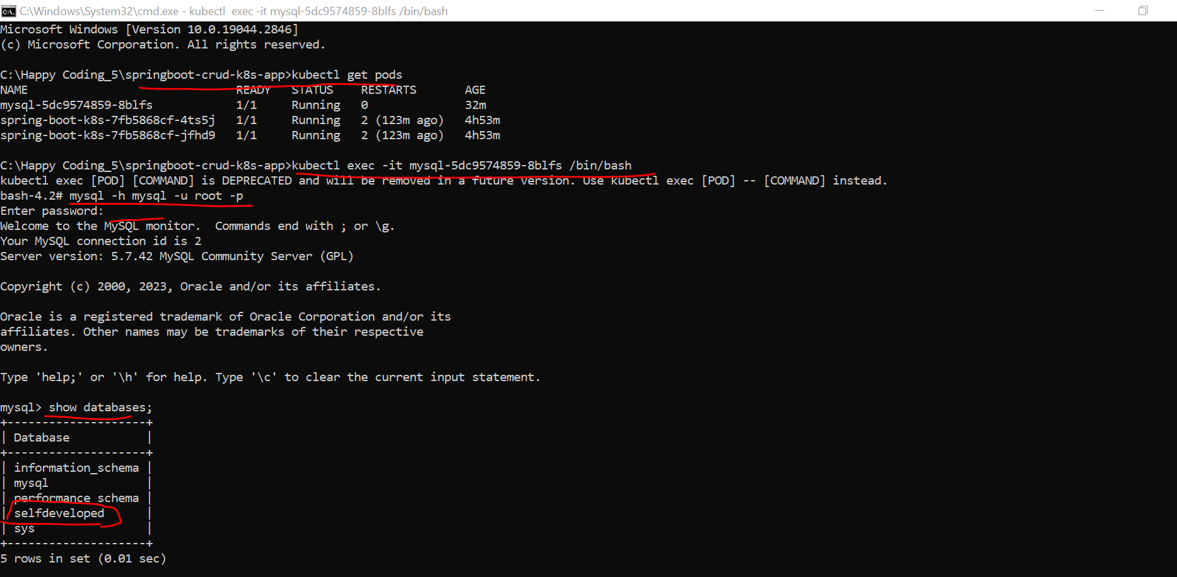

Now we verified that our mysql instance is up and running…

-----------------------------------------------------xxxxxxxxxxxxxxxxxxxxxxxx-------------------------------------------------

Now we can start and deploy our application to Kubernates cluster. But before that if u go to ur springboot app. And if you go to your application.yaml file here we configured our local database configuration.

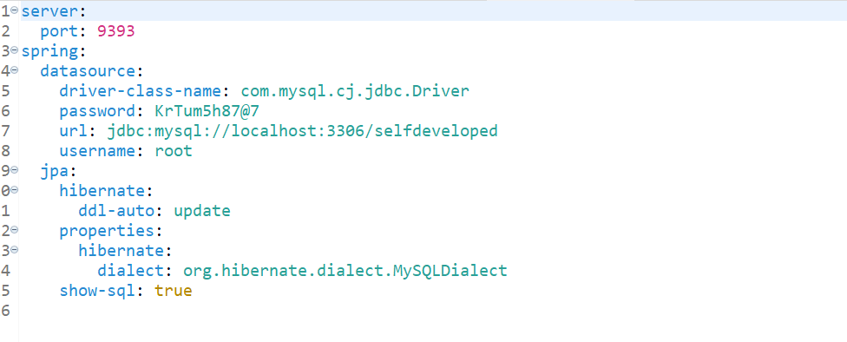

**Which is running in my local machine. So, we need to change this to pod configuration. Like mysql pod which is running in my Kubernates cluster. So, for now let’s make those field dynamic later we can fetch that information from app-deployment.yaml file.**

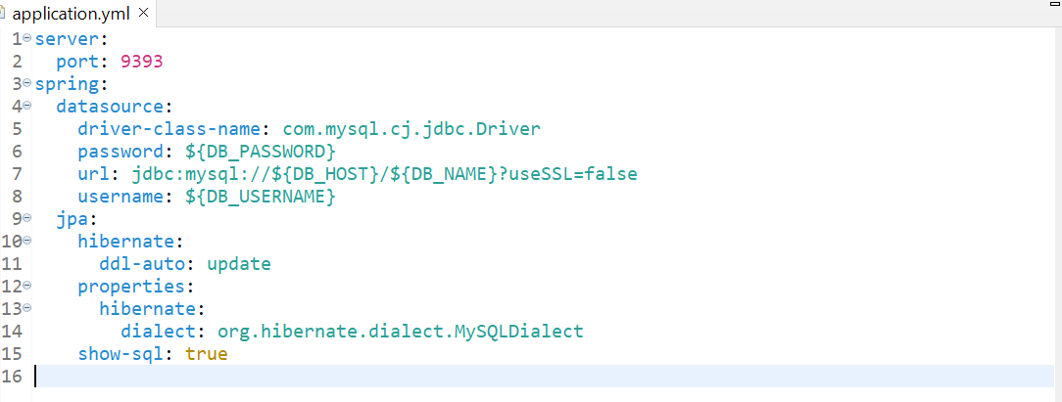

Now we can build docker image of our spring boot application. Now the rest part is we are going to create the docker image, deployment object and service object of our spring boot application.

Now we are in our current directory.

**++ docker build -t springboot-crud-k8s-app:1.0 .**

Now we build our docker image of our spring boot application and also if u observed also, we created the mysql images.

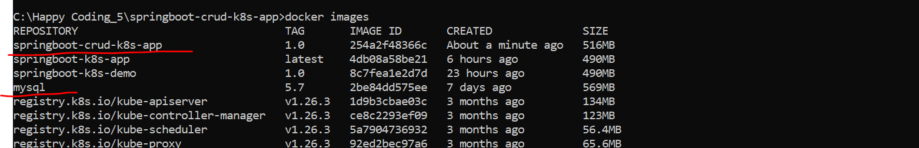

So, when we created the deployment object of mysql it pulls the mysql image with the tag 5.7 from docker hub that’s why u can see here particular mysql particular instance.

Now we need to create the service and deployment object of my spring boot application.

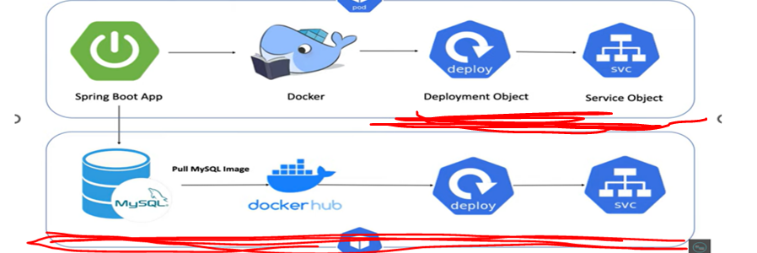

So, for that we just need to create the yaml configuration. We already added one yaml for mysql (**db-deployment.yaml**) now I am going to add another one for my spring boot crud application. we just need to create a service and deployment object.

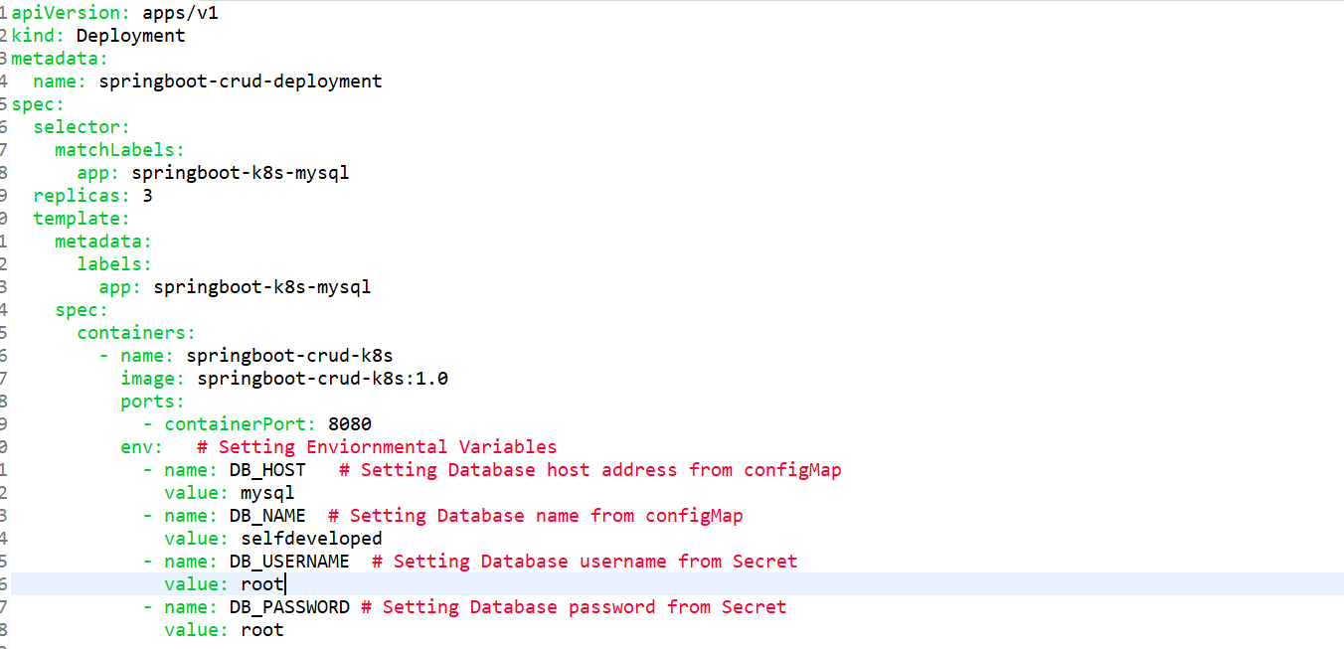

I just created the deployment object. Where I tell to the Kubernates created 3 replica means there will be 4 pods for this particular deployment object. This is what the image springboot-crud-k8s-app:1.0.

I am telling to the Kubernates get this image from my docker and just run it inside a Kubernates pod. And this is what we specified to get connected from my spring boot app to mysql instance. As we have given in application.yaml to pic db details from mysql instance.

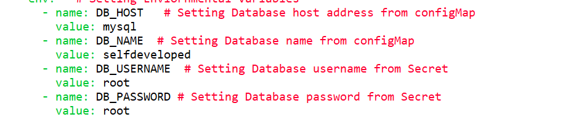

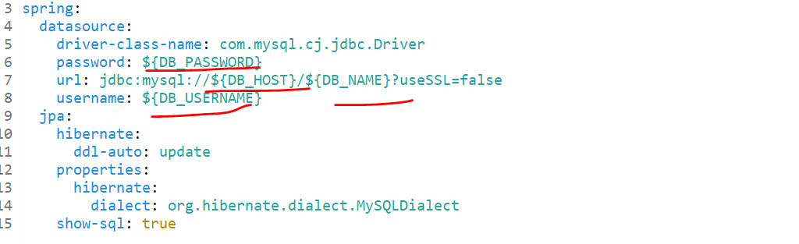

These 4 properties DB_HOST, DB_NAME, DB_USERNAME, DB_PASSWORD

Will get bind from the app.deployment.so make sure the key u pass here same u configure in ur application.yaml file.

So, if u come down there is a service object. So, 2 objects we created as per app-deployment.yaml file deployment object and service object.

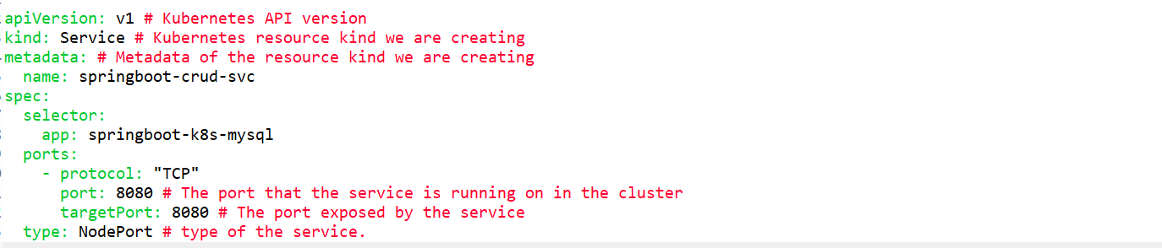

* So inside service object we are specifying service type as **NodePort** this is what the port and this is what the target port.
* Now I want to execute this app-deployment.yaml file. So, it will just create the deployment and service object of my spring boot crud application.

**++ kubectl apply -f app-deployment.yaml**



So it created deployment and service object.

**++ kubectl get deployments**

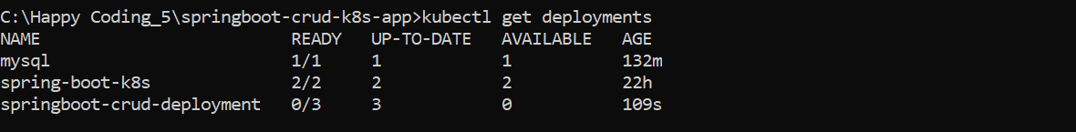

**++ kubectl get svc**

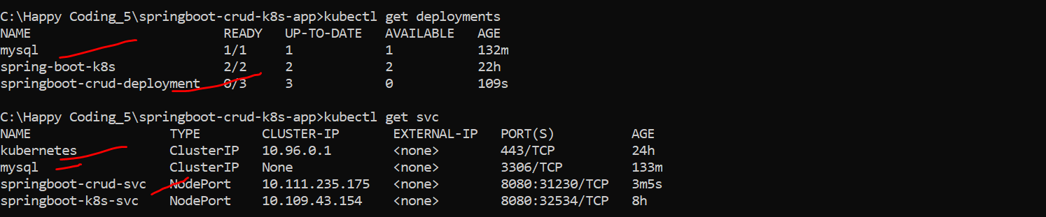

So there is 2 deployment and 3 services.

**++ kubectl get pods**

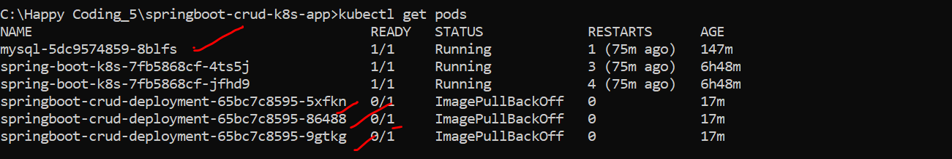

**++ kubectl get svc**

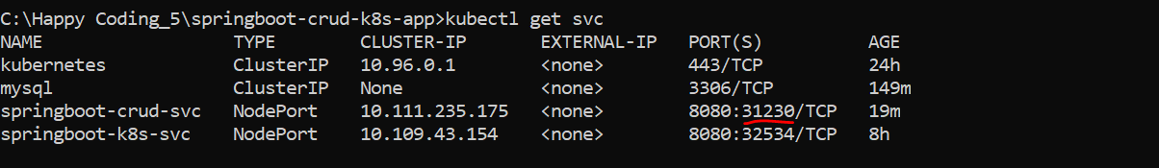

This is what the port where mt spring boot crud application is running.

Now I can get the ip either from node or directly using ip.



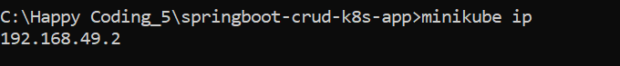

It will give the node ip.

So, with this host or particular ip and port I can able to access my crud app out of container.

Before access it let’s verify in my sql connection whether it created database or not. Open cmd and check.

---------------------------------------************************-------------------------

**++ kubectl exec -it mysql-5dc9574859-8blfs /bin/bash**

**++ mysql -h mysql -u root -p Enter->(it will ask for pwd so pwd is also root)**

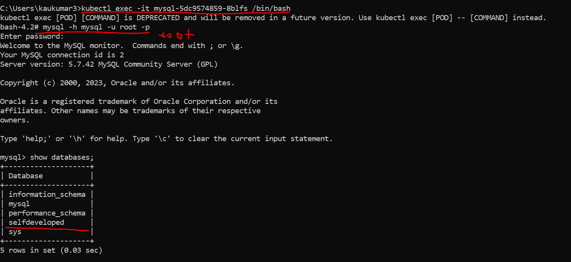

------------------------------------------------------------------------------------------------------------

Let’s try to access our crud app from browser.

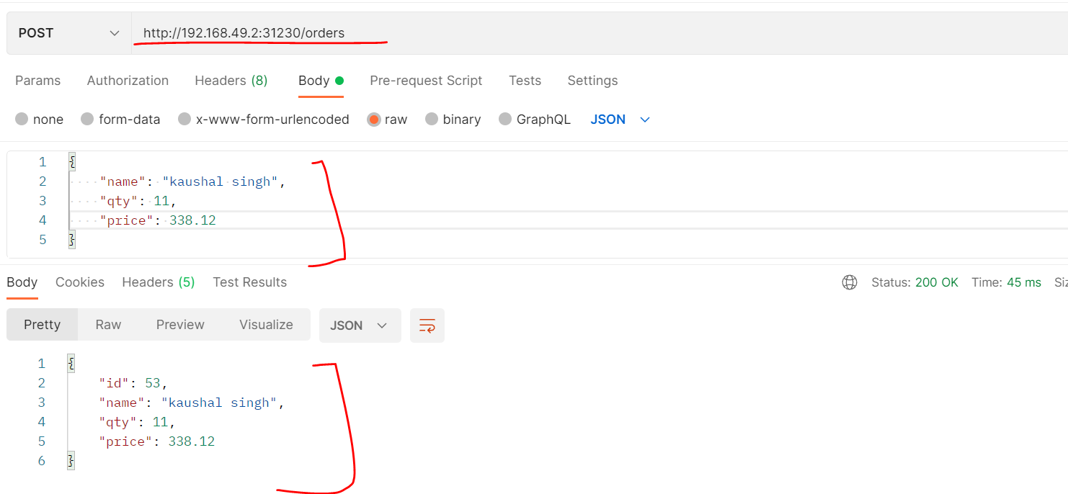

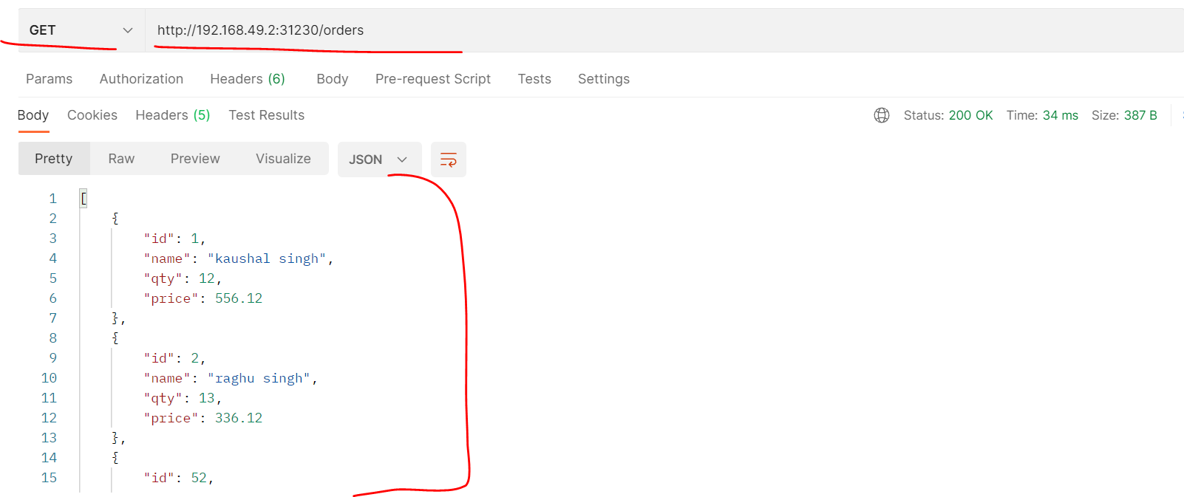

Now let’s do health check of each pods…let’s go to Kubernates dashboard.

**++ minikube dashboard**

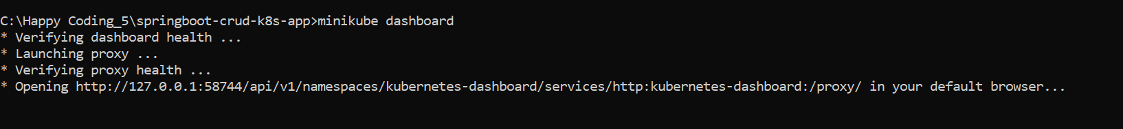

[Kubernetes Dashboard](http://127.0.0.1:58744/api/v1/namespaces/kubernetes-dashboard/services/http:kubernetes-dashboard:/proxy/#/workloads?namespace=default)

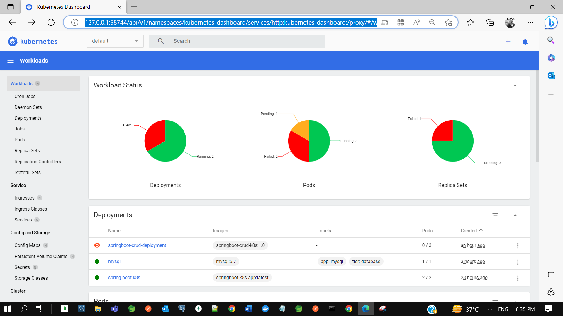

So there are 2 deployment 1 for spring boot crud and another for mysql instance

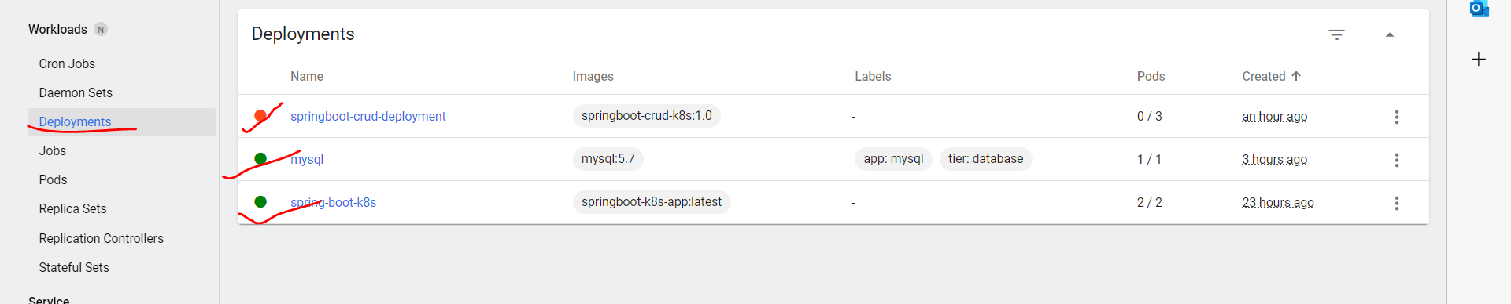

So total 4 pod 1 for my sql , and 3 replicas for crud app.

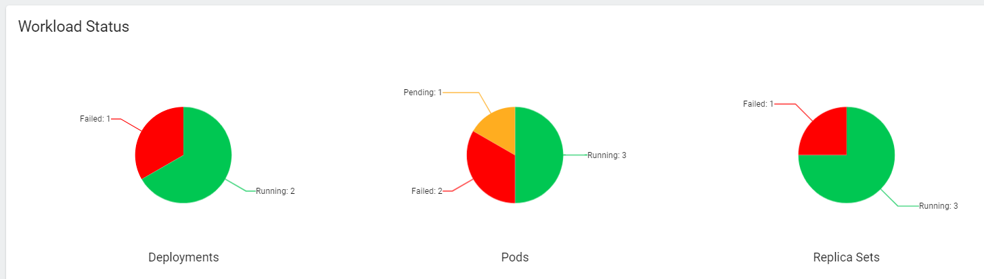

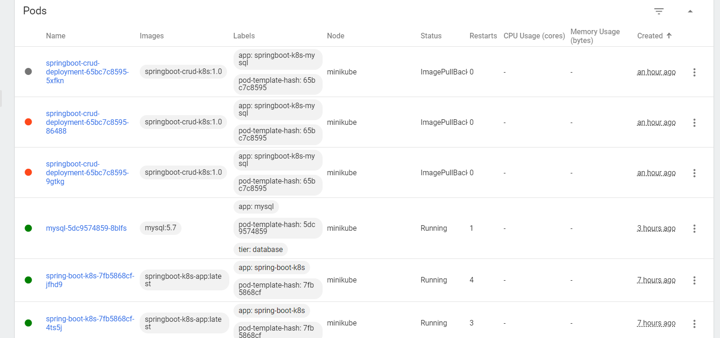

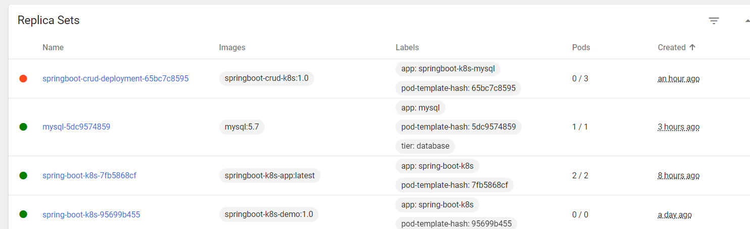

* **Kubernetes Tutorial | ConfigMap & Secrets Implementation in Spring Boot CRUD Example**

In the previous tutorial We understand how to deploy a spring boot mysql crud application in Kubernates cluster, But if you observe the code we hardcoded all data source properties in application So if you will go to the **app**-**deployment**.**yml** file, you can see here We just hardcoded **dbhost database name database username and database password**, These are the sensitive information of my application, which is not a good practice to hardcode if you hardcode this kind of sensitive information in your code Then your application itself is not secure So to avoid that we should always keep that sensitive information outside of the application with encrypted format.

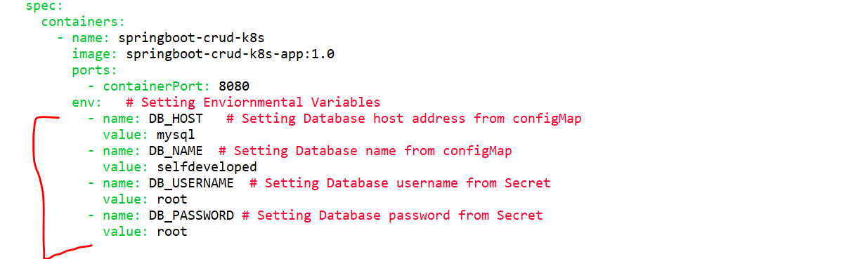

Since we are using containerization platform Kubernates itself provide us two components to store these kind of inputs So let's understand those two components which will help us to manage our configuration. So, Kubernates provide **Config Map** and **Secret** as two separate components to store your sensitive information so, there is two component config map and secret first of all, both are present outside of the pods. So, within a node all the pods can access to that particular **config map** and **secrets** and the basic difference between these two Config maps usually store information as plain text with key value pair pattern or key value pair format, where secrets store the information in encrypted text. This is what the basic difference between these two components. So now as per our application design We can keep our username and password inside secret because this must need to be encrypted Right and then database host and database name, we can keep it inside config map Because these two are not sensitive information so we can store them as a plain text.

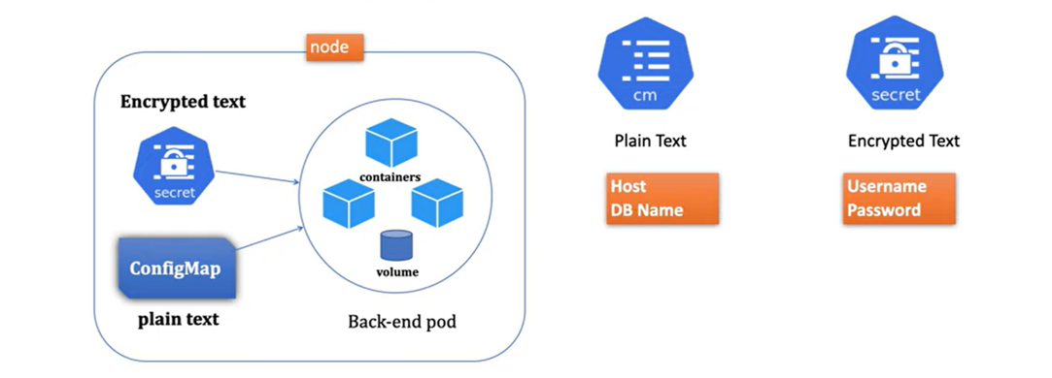

App name- **springboot-crud-k8s-configmap-secret-demo**

Dependencies**- Web, Data Jpa, MySQL, Lombok**

Now in our existing code we need to create two more yml file. One is for config map and another one for **secrets**. So first, let me create a **configMap**.**yaml** file. Then here first I need to specify API version. I Will just give v1 then you just need to provide kind it means you are telling the Kubernetes This is the object of config map, next you need to provide metadata, as part of metadata, you just need to provide a name of your config map. So, I will define a name db-config you can give any name here. Now the next you need to provide the what all information you want to keep in this config map, so that's the reason I will just give data, Then what all information we want to set here we just want to set the host and Database name, right so I can give you something like DB name, So host is nothing our mysql because this is what the config map here We can store the information as a plain text and this host and database name is not Sensitive information of my application so I can add them as a plain text So this database name I will give selfdeveloped

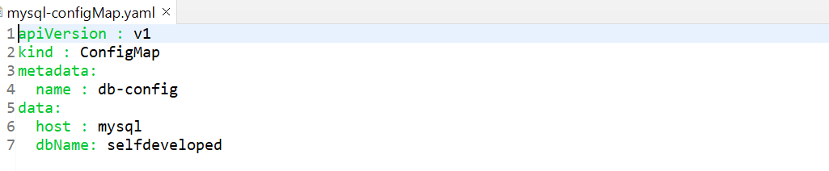

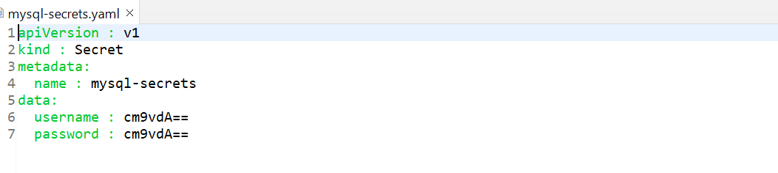

To Encrypt the username and password Kubernates provide one command---



now we will create a **secret.yaml** file. Then I will just give the name **mysql-secrets.yaml**. Then here you just need to provide the object name, which is secret and then metadata you can give any name of your secret I will just give mysql secrets. Then here we just need to provide the **username** and **password** Because this is what we just want to encrypt. So, I will just change the attribute here username and we just want to add password as root that will also in encrypted format.so, first let's encrypt our username and password.

now let's remove the hard-coded value from our application So, first go to the DB deployment.yaml file So, here if you observe mysql root password, we specified as a value directly root here.so, you just need to fetch it from the secret rather than hard-code it here. So what I will do I will just specify value from Then where you want to fetch it I will just fetch it from the Secret. so you are telling to the Kubernetes. I just want to fetch this mysql root password Value from secret key and give the name name of your secret. So, this DB host and database name I fetched from the config map, and this is what the host key I Configured in config map, and this is what the database name I configured in the config map. now similar way this username and password will fetch from the secret. So, now we didn't hard code any username password or anything sensitive information in our application. Now, all the information will fetch dynamically at runtime from this secret and this config map.

Now change in app-deployment.yaml and db-deployment.yaml file and refer all hardcoded value and refer it from ConfigMap and secret Kubernates component. So, our old app-deployment.yaml file is->

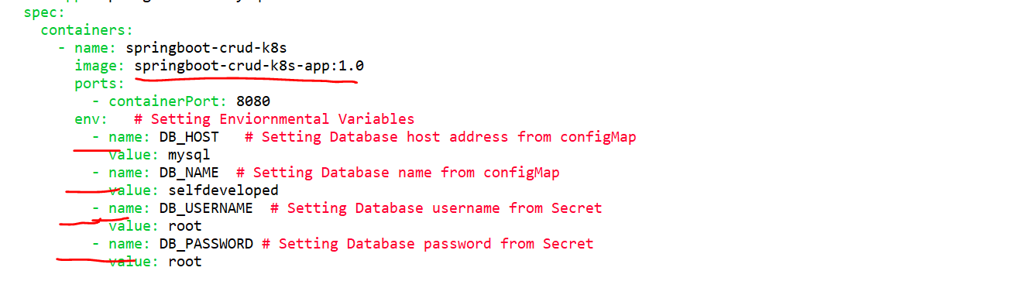

After changing our **app-deployment.yaml** file---

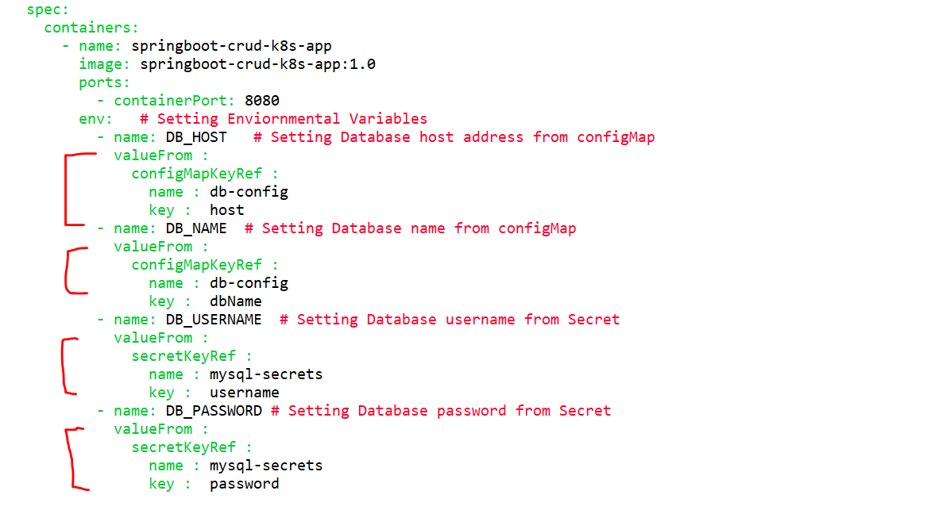

We are referring these values from **ConfigMap** and **secret** file.

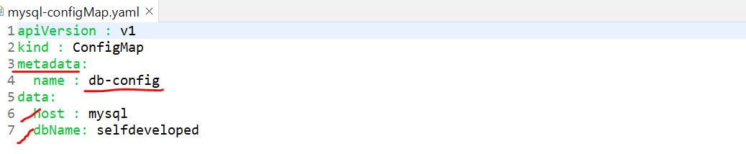

--------------------------------------------------------------------------------------------------------------------

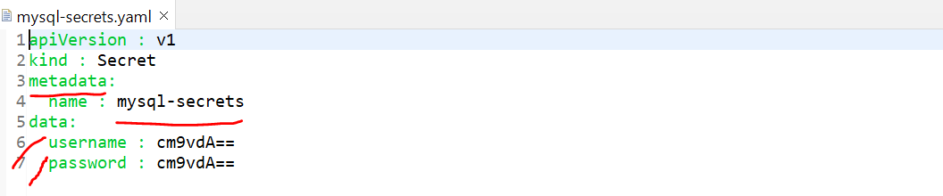

Now let’s change our **db-deployment.yaml** file as well where we given hardcoded let’s refer it from **ConfigMap** and **secret**. So old was--

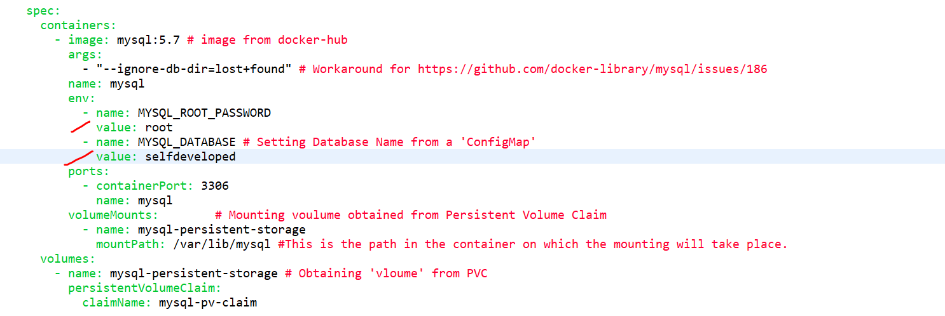

After changing **db-deployment.yaml--**

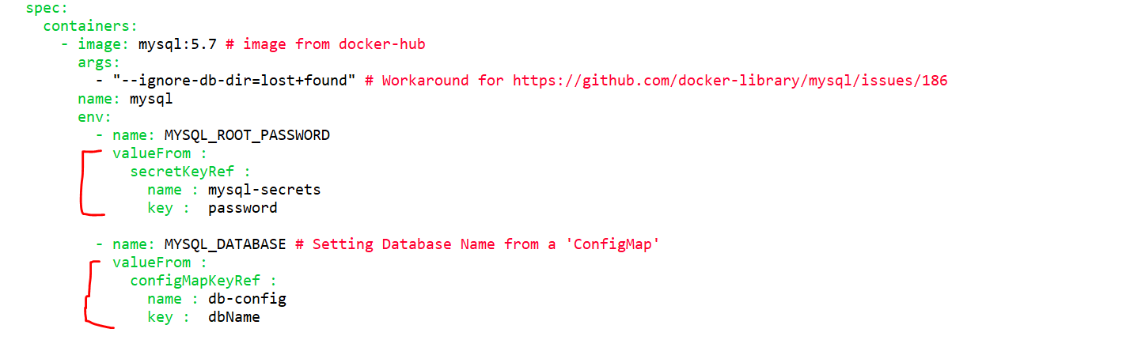

**Now let’s start our minikube---**

**++ minikube start**

Now we need to sink our minikube to local docker repository—

**++ minikube docker-env**

**++ @FOR /f "tokens=*" %i IN ('minikube -p minikube docker-env --shell cmd') DO @%i**

**++ docker images**

Our Dockerfile is-

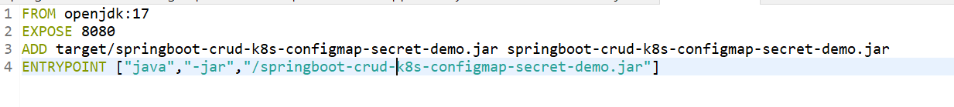

Go to your project directory

**++ cd C:\Happy Coding_5\springboot-crud-k8s-configmap-secret-demo**

Build docker image of our application

**++ docker build -t springboot-crud-k8s-configmap-secret-demo .**

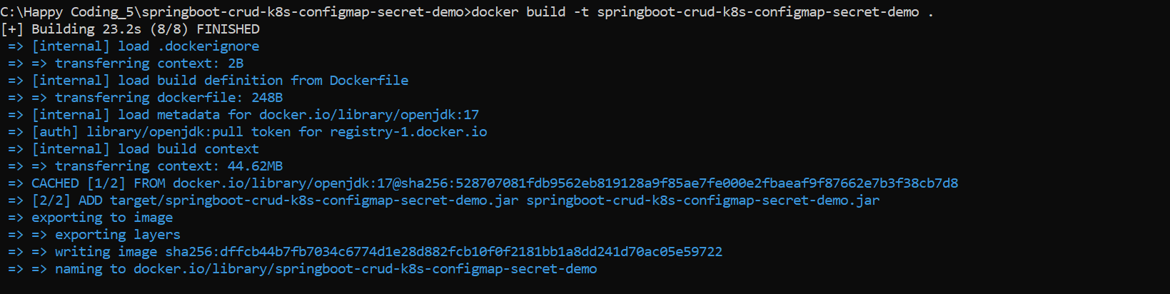



We are in current directory so,

* **first thing is we need to create a config map, first we need to deploy this ConfigMap object.**

**++ kubectl apply -f mysql-configMap.yaml**



To verify config map---

**++ kubectl get configmap**

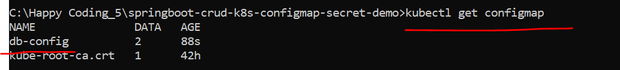

* **similar way let’s deploy the secret.**

**++ kubectl apply -f mysql-secrets.yaml**



To verify secrets---

**++ kubectl get secrets**



Now we deployed **ConfigMap** & **secrets** and now our **app-deployment.yaml** & **db-deployment.yaml** point to this **config** **map** and **secrets**.

Now let’s deploy the **db-deployment.yaml** file

**++ kubectl apply -f db-deployment.yaml**

To verify deployment object---

**++ kubectl get deployments**

To check the status of our pod where my sql instance running

**++ kubectl get pods**



If u want to check the log of ur mysql or pod

**++ kubectl logs mysql-85b5fc646-hfh9m**

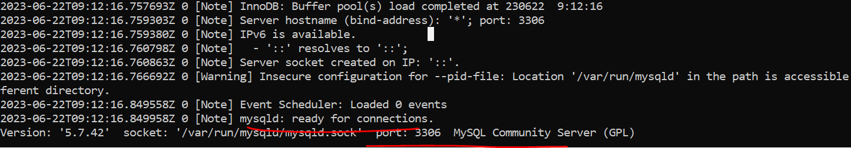

**Let’s verify open new terminal and can try**

I just want to connect to the mysql instance which is running on Kubernates cluster.

**++ kubectl exec -it mysql-85b5fc646-hfh9m /bin/bash**

**++ mysql -h mysql -u root -p**

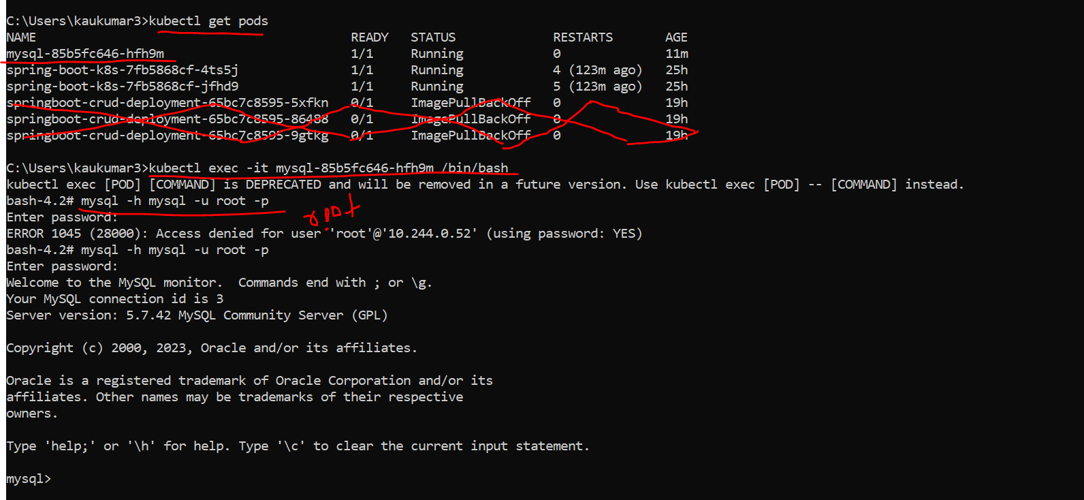

Where -it is an integrated terminal. -h is the host name specified. Pwd also is root only given.

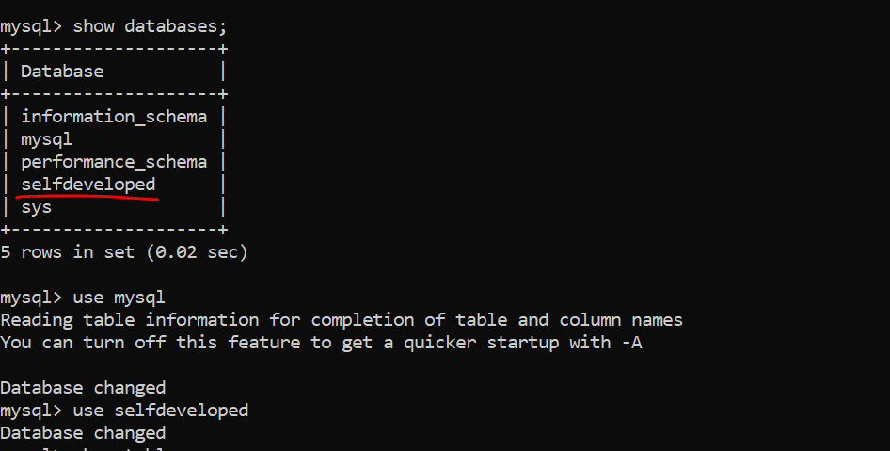

Now we deployed the **db-deployment.yaml** file.

Now next I need to deploy our **app-deployment.yaml** file.

Now the next step, we deployed the config map. We deployed the secrets. We deployed the db-deployment.yaml file. Now the next we need to deploy our app-deployment.yaml file where we just provided the deployment object. We are telling the Kubernetes read this particular Docker image and run it inside a Kubernetes pods. Similarly, we also created the service as a NodePort. We are telling the Kubernetes to expose my application outside to the Kubernetes cluster

**++ kubectl apply -f app-deployment.yaml**



So, deployment object and service object got creates.

If u want to check and verify **deployment/service/pods** let’s do that first—

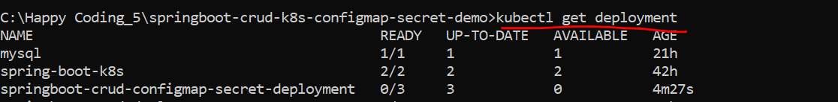

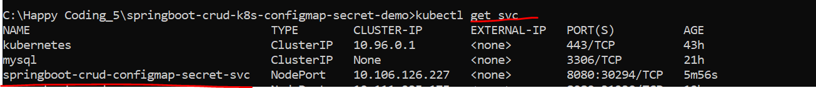

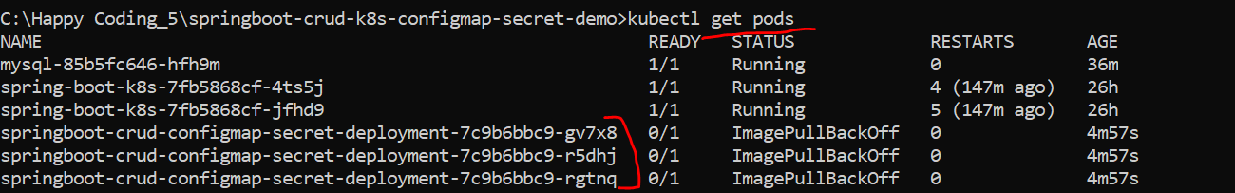

++ kubectl logs springboot-crud-configmap-secret-deployment-7c9b6bbc9-gv7x8



Since we exposed our application as a **NodePort** service type.

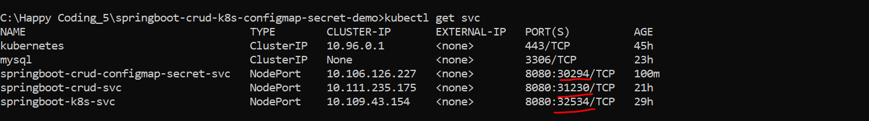



Now let’s try out this particular endpoint.

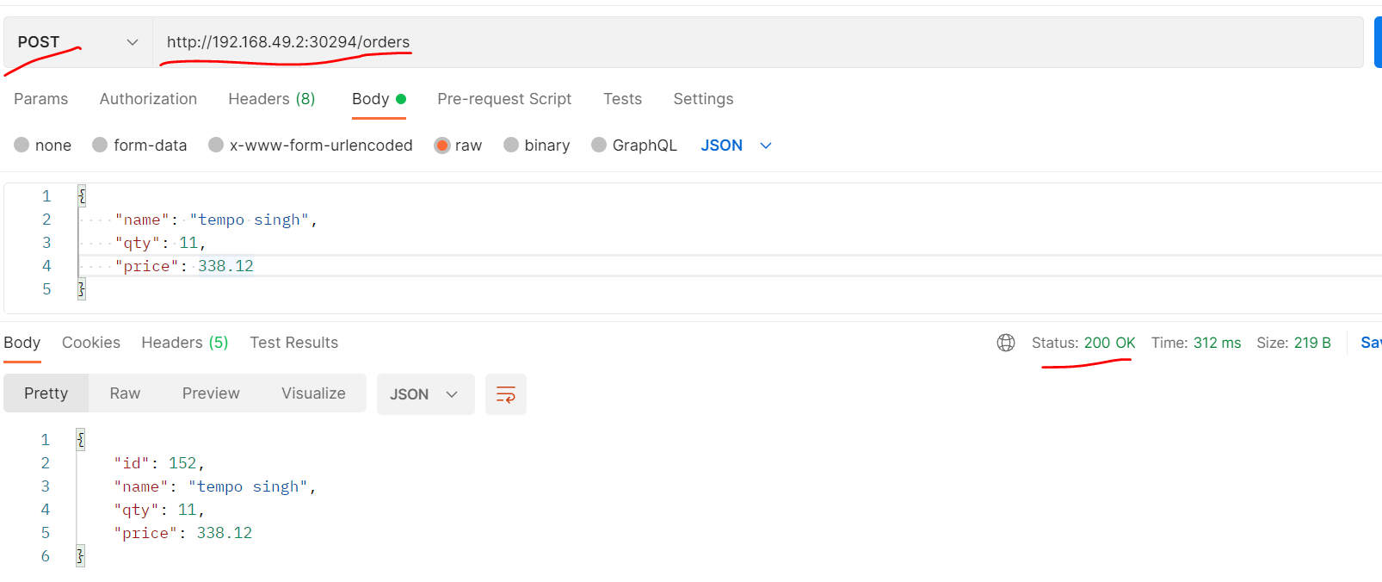

So, in this particular tutorial, we just understand how to Segregate sensitive information of your application to the outside to the pods. so that's the reason we just used two component **configmap** and **Secrets** in **secrets** we added the information in encrypted format and in config map We added the information in plain text and in both the DB deployment and app deployment Rather than hard code those details or sensitive information here. We either point to the **Secrets** or we point to the **config map** based on our required inputs.

To get the more details about Kubernates components let’s go to Kubernates **Dashboard**.

**++ minikube dashboard**

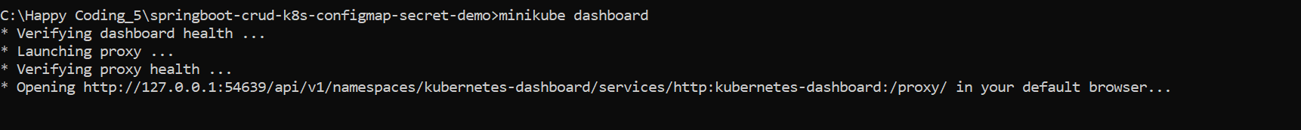

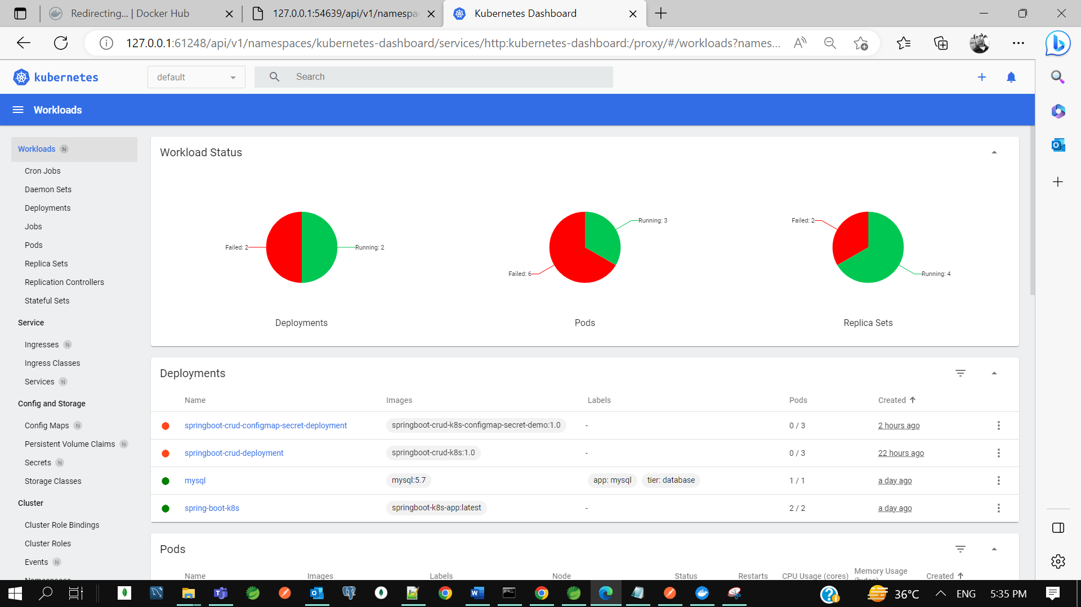

I just want to show you the config map and secrets component on Kubernates dashboard.

